

**TekExpress® USB4**

**Automated Test Solution Software**

**Application Help**

##### Register now!

##### Click the following link to protect your product. [tek.com/register](https://www.tek.com/product-registration)

#### *P077170204*

**077-1702-04 August 2025**

Copyright © 2025, Tektronix. 2025 All rights reserved. Licensed software products are owned by Tektronix or its subsidiaries or suppliers, and are protected by national copyright laws and international treaty provisions. Tektronix products are covered by U.S. and foreign patents, issued and pending. Information in this publication supersedes that in all previously published material. Specifications and

price change privileges reserved. All other trade names referenced are the service marks, trademarks, or registered trademarks of their respective companies.

TEKTRONIX and TEK are registered trademarks of Tektronix, Inc.

Tektronix, Inc. **-** 13725 SW Karl Braun Drive **-** P.O. Box 500 **-** Beaverton, OR 97077 **-** US

For product information, sales, service, and technical support visit [*tek.com*](http://www.tek.com/)to find contacts in your area. For warranty information visit

[*tek.com/warranty*](https://www.tek.com/warranty-status-search).

**Contents**

Welcome. 6

Getting help and support 7

Product documents 7

Conventions 7

Technical support 8

Getting started 9

Hardware requirements 9

Minimum system requirements 9

Supported instruments 9

Software requirements 10

Download and install the software 10

Activate the license 11

Check Software Version and License Key 11

Required windows 10 user account setting 11

Verify application installation 12

Required my TekExpress folder settings 12

Set my TekExpress folder permissions 12

Test files storage location 13

Setting up the test environment 14

Test process flow. 14

Deskew real-time oscilloscopes 14

Instrument and DUT connection setup 15

Equipment connection diagram 15

Running tests 16

Prerun checklist 16

Search instruments connected to the application 16

Starting the application 18

Application panels overview 18

Application controls 20

Options menu functions 21

Configure email settings 23

TekExpress instrument control settings 24

Setup panel: Configure the test setup 25

DUT: Set DUT settings 26

DUT automation setup. 29

Test Selection: Select the tests 30

Acquisitions: Set waveform acquisition settings 32

Running tests on prerecorded (saved) waveforms 34

Configuration: Set measurement limits for tests 36

Preferences: Set the test run preferences 38

Status panel: View the test execution status 39

View test execution status 39

View test execution logs 40

Results panel: View summary of test results 41

Filter the test results 41

Reports panel: Configure report generation settings 42

Report configuration settings 42

Configure report view settings 44

View a generated report 45

Saving and recalling test setup 46

Overview 46

Save the configured test setup 46

Load a saved test setup 47

Perform a test using pre-run session files 48

Save the test setup with a different name 53

SCPI Commands. 54

About SCPI command 54

Socket configuration for SCPI commands 54

Set or query the device name of application 60

Set or query the suite name of the application 60

Set or query the test name of the application 61

Set or query the general parameter values 76

Query the available devices in the DUT panel of the application 82

Query the available suites for the selected device 82

Query the list of available tests of the application 82

Query the available version names of the application 83

Query the list of available instruments based on the specified instrument type 83

Set or query the IP address of the instrument based on the specified instrument type 84

Query the information of the generated report file 84

Query the information of the generated waveform files 85

Query the information of the generated image files 85

Query the active TekExpress application name 85

Set or query the DUTID of application 86

Sets or query the acquire mode status 86

Set or query the execution mode status 87

Generate the report for the current session 87

Query the value of specified report header field in the report 88

Query the value of specified result detail available in report summary/details table 88

Restore the setup to default settings 89

Save the setup 89

Save the settings to a specified session 90

Open the setup from a specified session 90

Query the current setup file name 90

Run/stop/pause/resume the selected measurements execution in the application 91

Query the current measurement execution status 91

Query whether the current setup is saved or not saved 91

Exit or close the application 92

Query the status of the previous command execution 92

Query the last error occurred 92

Set or query the popup details 93

Sets or query the limit values in the limits editor window 93

Set or query the waveform file recalled for the specified test name and acquire type 94

Set or query the enable/disable status of Verbose function 94

Query the enable or disable status of Continuous run function. 95

Set or query the enable/disable status of Continuous Run function 95

Set or query the continuous run duration time value 96

Set or query the session create option in the continuous run function 97

Set or query the View report after generating option status 97

Returns the report as XML string 98

Copies all the images from current run session to the given destination location 98

Selects the specified test(s) and deselect all other tests 98

Returns the complete information about the selected test 99

Set the default session 99

Save the run/config sessions 100

Load the run/config session 100

Delete the run/config session 100

Run the run/config saved session 101

Query the available list in the run/config session 101

Query the current run/config session 101

Override the run/config session 102

Command parameters 102

Examples 112

References. 114

Application directories 114

File name extensions 115

View test-related files 115

Handle error codes 116

Index. 117

# Welcome

Welcome to the TekExpress® USB4 Automated Test Solution Software application (referred to as USB4 in the rest of the document). TekExpress USB4 provides an automated, simple, and efficient way to test USB4 transmitter interfaces and devices for USB-IF compliance through DPOJET1 for better margin, debugging, and analysis.

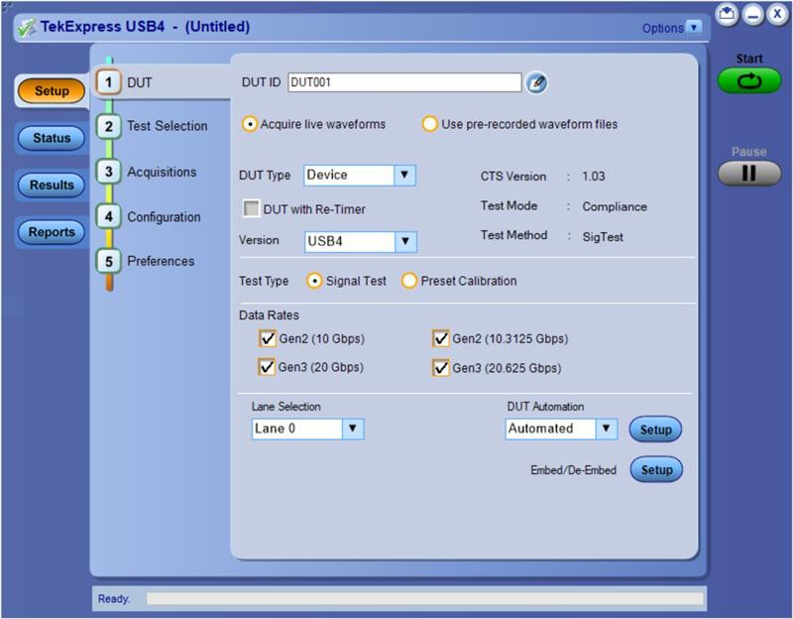

Key features and benefits

* Automated solution for USB4 connectors which support USB4 specification and CTS (Gen2 and Gen3)
* DPOJET plug-in for connectors which support USB4 specification and CTS (Gen2 and Gen3) with setup files and MOI.
* Support embedding Channels (2 m and 0.8 m) and their respective filter files for connectors.
* Manual support for compliance to debug with DPOJET USB4 and CIO plug-ins.
* SigTest (USB-IF Compliance Tool) integration for USB4 Gen2 and Gen3 device and host.

1 This feature is supported only for MSO/DPO70000 models

# Getting help and support

## Product documents

Use the product documents for more information on the application functions, understand the theory of operation, how to remotely program or operate the application, and do other tasks.

###### Table 1: TekExpress Application documents

|  |  |
| --- | --- |
| **To learn about** | **Use this document** |
| How to use the application  How to remotely control the instrument | TekExpress USB4 Help  PDF version of this document can be downloaded from [*www.tek.com/downloads*](http://www.tek.com/downloads)  Compiled HTML (CHM) version is integrated with the application. Press **F1** key from the keyboard to start the help.  Tektronix Part Number: 077-xxxx-xx |

## Conventions

This application help uses the following conventions:

* The term "Application," and "Software" refers to the TekExpress USB4 application.
* The term “DUT” is an abbreviation for Device Under Test.
* The term “select” is a generic term that applies to the two methods of choosing a screen item (button control, list item): using a mouse or using the touch screen.
* A **Note** identifies important information.

###### Table 2: Icons used in the help

|  |  |
| --- | --- |
| **Icon** | **Description** |
|  | This icon identifies important information |
|  | This icon identifies conditions or practices that could result in loss of data. |
|  | This icon identifies additional information that will help you use the application more efficiently. |

## Technical support

Tektronix values your feedback on our products. To help us serve you better, please send us your suggestions, ideas, or comments on your application or oscilloscope. Contact Tektronix through mail, telephone, or the Web site. See [*Contacting Tektronix*](http://www.tek.com/)at the front of this document for contact information.

When you contact Tektronix Technical Support, please include the following information (be as specific as possible):

##### General information

* All instrument model numbers
* Hardware options, if any
* Modules used
* Your name, company, mailing address, phone number, FAX number
* Please indicate if you would like to be contacted by Tektronix about your suggestion or comments.

##### Application specific information

* Software version number
* Description of the problem such that technical support can duplicate the problem
* If possible, save the setup files for all the instruments used and the application
* If possible, save the TekExpress setup files, log.xml, *.TekX (session files and folders), and status messages text file

# Getting started

## Hardware requirements

### Minimum system requirements

The following table shows the minimum system requirements needed for an oscilloscope to run TekExpress USB4.

###### Table 3: TekExpress USB4 system requirements

|  |  |
| --- | --- |
| **Component** | **Requirement** |
| Oscilloscope | See *Supported instruments* |
| Processor | Same as the oscilloscope |
| Operating System | Same as the oscilloscope:   * Windows 10 (64-bit only) SP1 *Windows 10 user account settings* |
| Memory | Same as the oscilloscope |
| Hard Disk | Same as the oscilloscope |
| Display | Super VGA resolution or higher video adapter (800 x 600 minimum video resolution for small fonts or 1024 x 768 minimum video resolution for large fonts). The application is best viewed at 96 dpi display settings 2 |
| Firmware | TekScope 10.12.0 and above (for Windows 10) |

### Supported instruments

###### Table 4: Required equipment

|  |  |
| --- | --- |
| **Resource** | **Model supported** |
| Real-time oscilloscope | * DPO714AX * Minimum bandwidth of 21 GHz * Tektronix DPO DX, SX series and SX Stack series with non ATI channels oscilloscope (Windows 10 OS) |
| Probes | * Two units of TCA SMA 292D adapter * One match pair SMA cable of 21 GHz bandwidth or above |
| USB4 fixture | * USB-IF approved Wilder-Tech fixtures for USB4 compliance testing. * Part number: USB4-TPAC-TF-LSX-CBL-FK | 640-1020-500 |
| Microcontroller (with power supply) | * The fixture set includes Tx Host and Device testing. * Part number: USB4-TPA-UC | 640-0962-000 |
| Cables | * USB 3 ft Type A – Type B Male (to connect Microcontroller to Oscilloscope) * Type C to Type C cable of 40 Gbps (to connect Microcontroller to Test Fixture) |
| Table continued… | |

2 If TekExpress is running on an instrument that has a video resolution less than 800x600, connect and configure a second monitor to the instrument.

|  |  |
| --- | --- |
| **Resource** | **Model supported** |
| Ultra sync cable | Supports DPO SX series oscilloscope with bandwidth of 33, 50, 59, and 70 GHz and is only applicable for dual-stack. |

##### See also

*Minimum system requirements*

## Software requirements

###### Table 5: Minimum software license requirements

|  |  |
| --- | --- |
| **Software** | **Details** |
| Matlab Compiler Runtime (MCR) | For SigTest 0.95, MCR 2024a v24.1 is required. For SigTest 0.87, MCR R2021b v9.11 is required  **Note:** TekExpress Tx USB4V1 compliance solution supports SigTest version 0.95 on the DPO714AX. Other oscilloscope models are supported with SigTest version 0.87. |
| Electrical Test Tool (ETT) used for USB compliance testing | ETT Version 1.1.2 or above |
| DPOJET1 | Jitter and Eye Analysis Tool (version 10.5.0 or higher) with Advanced Jitter and Eye analysis (DJA option) installed |
| Serial Data Link Analysis (SDLA)1 | version 3.0.13 or later, for Channel De- Embed, for custom filter development1. |
| Microsoft Internet Explorer | Version 7.0 SP1 or later, or other Web browser for viewing reports. |
| Adobe Reader software | Version 7.0 or later for viewing portable document format (PDF) files |

### Download and install the software

Complete the following steps to download and install the latest TekExpress USB4 application.

1. Go to [*www.tek.com*](http://www.tek.com/).
2. 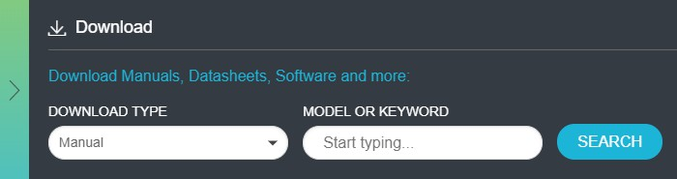Click **Downloads**. In the Downloads menu, select DOWNLOAD TYPE as Software and enter the application name in the MODEL OR KEYWORD field and click **SEARCH**.
3. Select the latest version of software and follow the instructions to download the software. Copy the executable file into the oscilloscope.
4. Double-click the executable and follow the on-screen instructions.

The software is installed at C:\Program Files\Tektronix\TekExpress\TekExpress USB4.

1. Select **Application/Analyze** > **TekExpress USB4** from the Oscilloscope menu, to open the application.

### Activate the license

To activate the license, access the oscilloscope’s help documentation, navigate to the **License Activation** section, and follow the on-screen instructions using the oscilloscope interface.

### Check Software Version and License Key

To view version information of the application, click **Options > About TekExpress**.

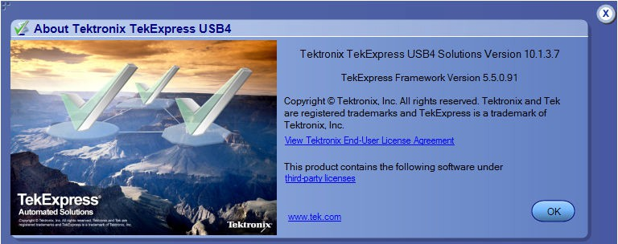

### Required windows 10 user account setting

Windows 10 instruments need to have the User Account Control Settings set to **Never Notify**. To set User Account Control Settings:

1. Go to Control Panel > User Accounts > Change User Account Control settings.
2. Set the sliding control to **Never Notify** as shown in the image, and click **OK**.

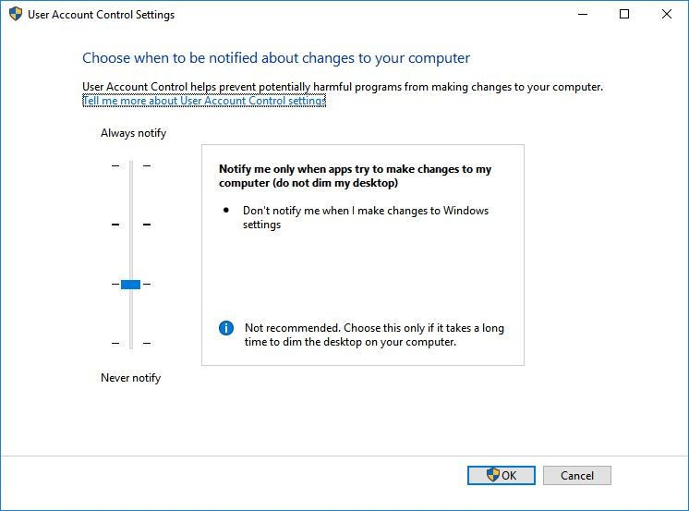

*Figure 1: Windows 10 User Account Control Settings*

##### See also

*Supported oscilloscopes*

### Verify application installation

To verify the installation was successful:

1. Open the TekScope application.
2. Click the **Analyze** menu.
3. Verify that TekExpress USB4 is listed in the Analyze menu.
4. Click **TekExpress USB4** to open the application. Verify that the application opens successfully.

### Required my TekExpress folder settings

Before you run tests for the first time, you need to *Set the My TekExpress folder permissions*.

### Set my TekExpress folder permissions

Ensure that the My TekExpress folder has read and write access. Also verify that the folder is not set to be encrypted:

1. Right-click the folder and select **Properties**.
2. Select the **General** tab, and then click **Advanced**.
3. In the Advance Attributes dialog box, ensure that the option Encrypt contents to secure data is NOT selected.

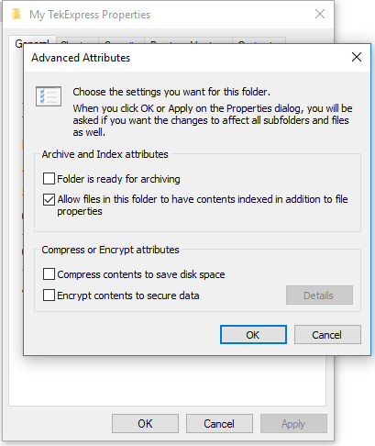

1. Click the **Security** tab and verify that the correct read and write permissions are set.

### Test files storage location

When you launch TekExpress USB4 for the first time, it creates the following folders on the oscilloscope:

* + \My Documents\My TekExpress\USB4
  + \My Documents\My TekExpress\USB4\Untitled Session

Every time you launch TekExpress USB4, an Untitled Session folder is created in the USB4 folder. The Untitled Session folder is automatically deleted when you exit the USB4 application. To preserve your test session files, save the test setup before exiting the TekExpress application.

**CAUTION:** Do not modify any of the session files or folders because this may result in loss of data or corrupted session files. Each session has multiple files associated with it. When you save a session, the application creates a .TekX file, and a folder named for the session that contains associated files, on the oscilloscope X: drive.

##### See also

*Set the My TekExpress folder permissions**Application directories*on page 114

*File name extensions*on page 115

# Setting up the test environment

## Test process flow

Use the following list to set up and performing USB4 tests.

1. Allow test instruments to warm up (~20 minutes).
2. *Deskew the real-time oscilloscope*.
3. *Set up test equipment*.
4. *Verify that required instruments are connected to USB4*.
5. *Set DUT settings*.
6. *Select the tests*.
7. *View acquisition settings*.
8. Set global signal-related parameters.
9. *Select test notification preferences*.
10. *Select report options*.
11. *Check the prerun checklist*
12. Click **Start** to *Run tests*.

## Deskew real-time oscilloscopes

Use the following procedure to deskew direct input SMA channels on a real time oscilloscope.

**Note:** DPOJET has an automatic deskew option under. Refer to your DPOJET online help for information on how to deskew the channels.

1. Run Signal Path Compensation (SPC) on the oscilloscope.
2. Connect a SMA Power Splitter (preferred) or SMA 50 Ω coaxial “T” connector to the Fast Edge output of the oscilloscope.
3. Connect SMA cables from each of the two channels to be deskewed to the power splitter (or SMA coaxial “T” connector). It is best

to use matched cables when making high speed serial measurements. **It is important to use the same cables during deskew that you will use for subsequent measurements**.

1. Select **Default Setup**, and then select **Autoset** on the oscilloscope front panel.
2. Set the oscilloscope for 70% to 90% full screen amplitude on both channels. Center both traces so that they overlap.
3. Make sure that volts/div, position, and offset are identical for the two channels being deskewed.
4. Set the time/div to approximately 100 ps/div or less, with sample rate at 1 ps/pt. These settings are not critical, but should be close.
5. Set the horizontal acquisition mode to average, which provides a more stable display.
6. Select **Deskew** from the **Vertical** menu.
7. Verify that the reference channel (typically CH1 or CH2) is set to 0 ps deskew.
8. In the deskew control window, select the channel to deskew (typically CH3 or CH4). Adjust the deskew to overlay the rising edge as best as possible.

**Note:** Typical values are in the 10’s of ps or less with cables connected directly from Fast Edge to SMA inputs. If you are using

a switch box (for example, Keithley), deskew the complete path from where the test fixture connects, through the switch, and into the oscilloscope. Deskew values in these cases may be as much as 30 ps or more.

**Note:** There can be significant differences in the skew between two TCA-SMA adapters. If you find that a system requires a very large correction, obtain a pair of TCA-SMA adapters that closely match each other to reduce the amount of correction.

**Note:** TekExpress retains the user configured Deskew values, and does not override the values during test runs.

## Instrument and DUT connection setup

Click the **Setup > Test Selection > Schematic** button to open a PDF file that shows the compliance test setup diagrams (instrument, DUT, and cabling) for supported testing configurations.

##### See also

*Minimum system requirements*

*Search instruments connected to the application*on page 16

### Equipment connection diagram

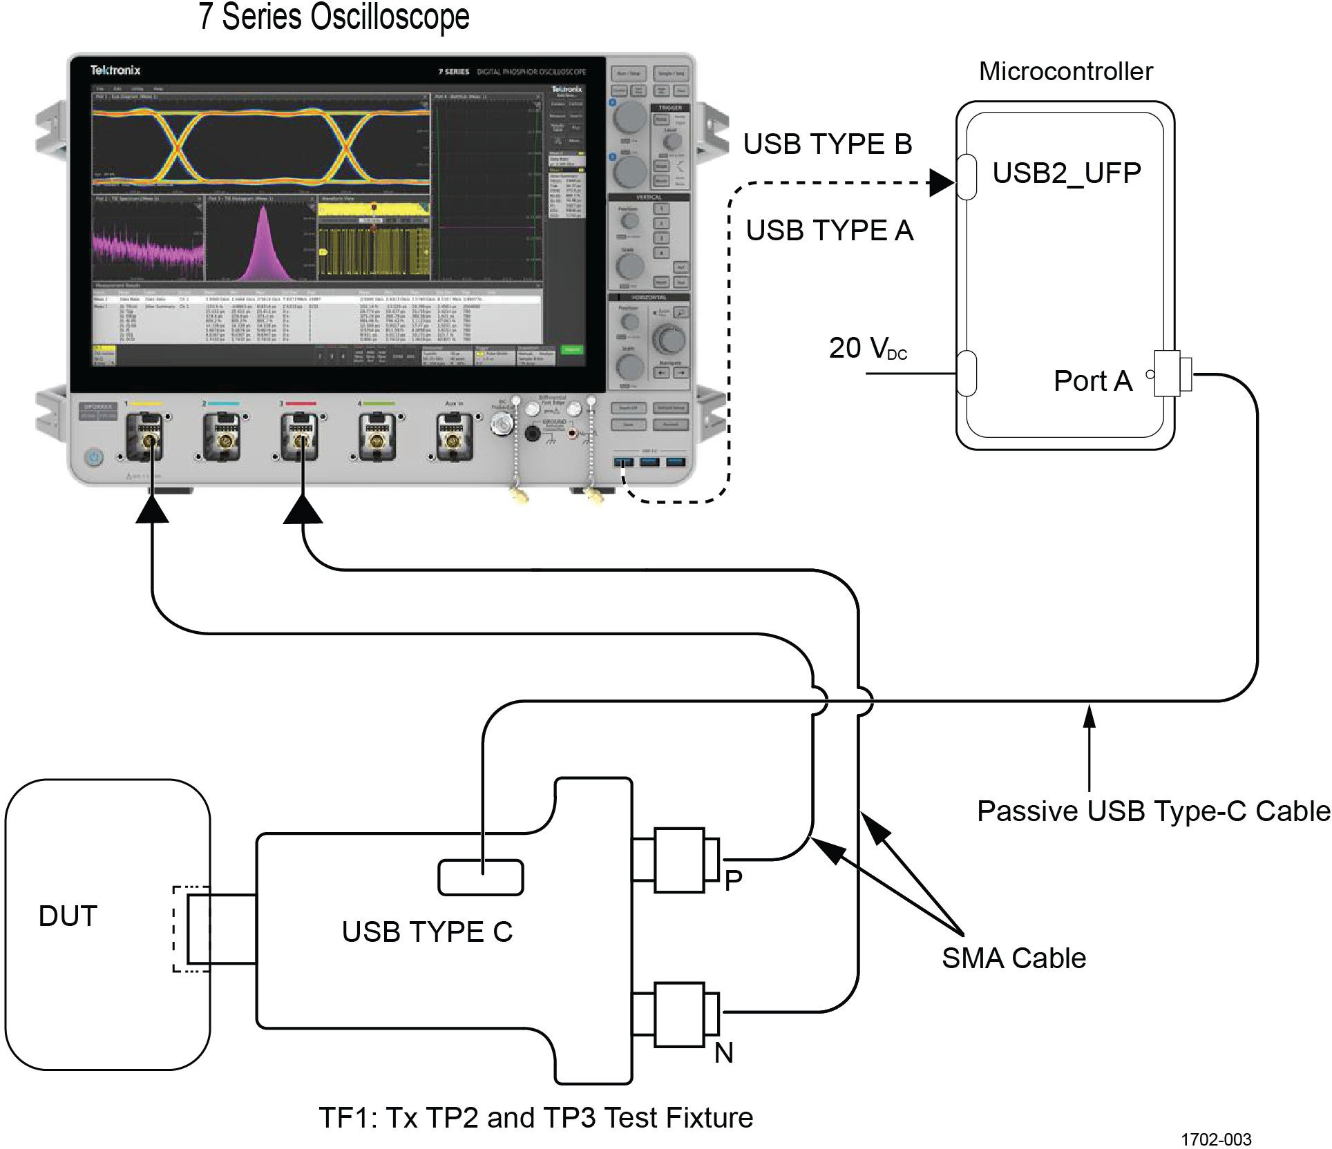

*Figure 2: Tektronix USB4 Transmitter connection diagram*

## Running tests

After selecting and configuring tests, review the *prerun checklist*and then click **Start** to run the tests. While tests are running, you cannot access the Setup or Reports panels. To monitor the test progress, switch back and forth between the Status panel and the Results panel.

The application displays a report when the tests are complete. While the tests are running, other applications may display windows in the background. The TekScope application takes precedence over other applications, but you can switch to other applications by using the **Alt**

**+ Tab** key combination. To keep the TekExpress USB4 application on top, select **Keep On Top** from the TekExpress Options menu.

##### See also

*Configuration tab parameters*

## Prerun checklist

Do the following before you click Start to run a test:

**Note:** If this is the first time you are running a test on the application, make sure that you have done the steps in *Required My**TekExpress folder settings*before continuing.

1. Make sure that all the required instruments are properly warmed up (approximately 20 minutes).
2. Perform Signal Path Compensation (SPC)
   1. On the oscilloscope main menu, select the **Utilities** menu.
   2. Select **Instrument Calibration**.
   3. Follow the on-screen instructions.
3. Verify that the correct instruments are connected (oscilloscope and signal sources):
   1. In TekExpress USB4, click **Setup > Configuration**.
   2. Click **Global Settings**.
   3. In the **Instruments Detected** list, verify that the test setup instruments are shown. If they are not, click the arrow button to list and select from all detected instruments. If the required instrument is still not listed, use the TekExpress Instrument Control Settings dialog box to scan for and detect instruments (See *Search instruments connected to the application*on page 16 ).

## Search instruments connected to the application

Use the TekExpress Instrument Control Settings dialog box to search the instruments (resources) connected to the application. The application uses TekVISA to discover the connected instruments.

 **Note:** The instruments required for the test setup must be connected and detected by the application, before running the test. To refresh the list of connected instruments:

1. Select Options > Instrument Control Settings.
2. In the **Search Criteria** section of the **Instrument Control Settings** dialog box, select the connection types of the instruments to search. Instrument search is based on the VISA layer, but different connections determine the resource type, such as LAN, GPIB, and USB. For example, if you choose LAN, the search will include all the instruments supported by the TekExpress that are communicating over the LAN.
3. Click **Refresh**. The TekExpress application searches for the connected instruments.

Search status of the instruments connected to LAN

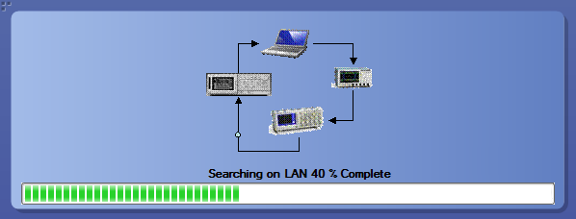

1. When the search is complete, a dialog box lists the instrument-related details based on the search criteria. For example, for the Search Criteria as GPIB, the application displays all the GPIB instruments connected to the application.

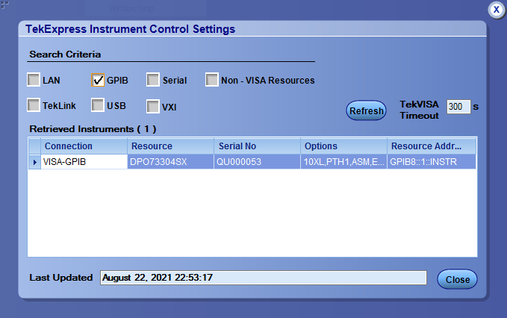TekExpress Instrument Control Settings window.

The details of the instruments are displayed in the Retrieved Instruments table. The time and date of instrument refresh is displayed in the Last Updated field.

# Starting the application

To start the TekExpress USB4, select from the oscilloscope menu bar **Applications/Analyze > TekExpress USB4**.



During start, a "My TekExpress" folder is created in the Documents folder of the current user and gets mapped to "X" drive. When the application is closed properly, the "X" drive gets unmapped. Session files are then stored inside the X:\USB4 folder. If this file is not found, the application runs an instrument discovery program to detect connected instruments before starting TekExpress USB4.

To keep the TekExpress USB4 application on top of any application, select **Keep On Top** from the *options menu*. If the application goes behind the oscilloscope application, select **Applications/Analyze >TekExpress USB4** to bring the application to the front.

## Application panels overview

TekExpress USB4 uses panels to group related configuration, test, and results settings. Click a button to open the associated panel. A panel may have one or more tabs that list the selections available in that panel. Controls in a panel can change depending on settings made in that panel or another panel.



###### Table 6: Application panels overview

|  |  |
| --- | --- |
| **Panel Name** | **Purpose** |
| *Setup* | The Setup panel shows the test setup controls. Click the **Setup** button to open this panel. Use this panel to:   * *Select DUT parameters* * *Select the test(s)* * *Set acquisitions parameters*for selected tests. * *Select test notification preferences* * *Set configuration tab parameters* |
| *Status* | View the progress and analysis status of the selected tests, and view test logs. |
| *Results* | View a summary of test results and select result viewing preferences. |
| *Reports* | Browse for reports, save reports as specific file types, specify report naming conventions, select report content to include (such as summary information, detailed information,  user comments, setup configuration, application configuration), and select report viewing options. |

##### See also

*Application controls*

## Application controls

This section describes the application controls with functionality and its details.

###### Table 7: Application control description

|  |  |
| --- | --- |
| **Item** | **Description** |
| *Options menu* | Menu to display global application controls. |
| Test panel | Controls that open tabs for configuring test settings and options. |
| Start / Stop button | Use the **Start** button to start the test run of the measurements in the selected order. If prior acquired measurements are not cleared, then new measurements are added to the existing set. The button toggles to the Stop mode while tests are running. Use the **Stop** button to abort the test. |
| Pause / Continue button | Use the **Pause** button to pause the acquisition. When a test is paused, this button changes as **Continue**. |
| Clear button | Use the **Clear** button to clear all existing measurement results. Adding or deleting a measurement, or changing a configuration parameter of an existing measurement, also clears measurements. This is to prevent the accumulation of measurement statistics or sets of statistics that are not coherent. This button is available only on *Results panel*.  **Note:** This button is visible only when there are results data on the panel. |
| Application window move icon | Place the cursor over the top of the application window to move the application window to the desired location |
| Minimize icon | Minimizes the application. |
| Close icon | Close the application. |
| Table continued… | |

|  |  |
| --- | --- |
| **Item** | **Description** |
| Mini view / Normal view | Mini view displays the run messages with the time stamp, progress bar, Start / Stop button, and Pause / Continue button. The application moves to mini view when you click the **Start** button. |

## Options menu functions

To access the **Options** menu, click  in the upper-right corner of the application. It has the following selections:

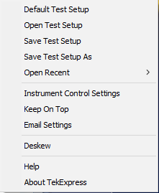

###### Table 8: Options menu settings

|  |  |
| --- | --- |
| **Menu** | **Function** |
| Default Test Setup | Opens a new test setup with default configurations. |
| Open Test Setup | Opens a previously saved test setup. Displays the list of previously saved test setup file names. Make the selection and click **OK** to open the test setup. |
| Save Test Setup | Saves the current test configurations with the specified file name. |
| Save Test Setup As | Saves the current test setup with a different file name or file type. |
| Open Recent | Displays the recently opened test setup file names. Make the selection and click **OK** to open the test setup. |
| *Instrument Control Settings* | Detects, lists, and refreshes the connected instruments found on the specified connections (LAN, GPIB, USB, Serial, Non-VISA Resources, TekLink, and VXI). |
| Keep On Top | Always keeps the TekExpress USB4 application on top of all the applications. |
| *Email Settings* | Configures email options for test run and result notifications. |
| Help | Displays the TekExpress USB4 help. |
| About TekExpress | Displays the application name, version, and hyperlink to end the user license agreement. |

## Configure email settings

Use the **Email Settings** utility to get notified by email when a measurement completes or produces any error condition. Follow the steps to configure email settings:

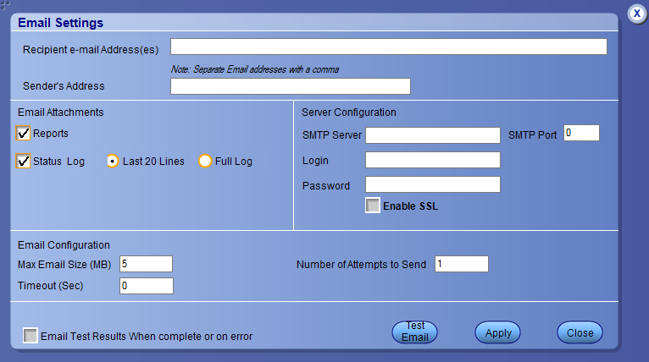

*Figure 3: Email settings window*

1. Select **Options > Email Settings** to open the Email Settings dialog box.
2. (Required) For **Recipient email Address(es)**, enter one or more recipient email addresses. To include multiple addresses, separate the addresses with commas.
3. (Required) For **Sender’s Address**, enter the email address used by the instrument. This address consists of the instrument name, followed by an underscore, followed by the instrument serial number, then the @ symbol, and the email server ID. For example: [user@yourcompany.com.](mailto:user@yourcompany.com)
4. (Required) In the **Server Configuration** section, type the SMTP Server address of the Mail server configured at the client location, and the SMTP Port number, in the corresponding fields.

If this server requires password authentication, enter a valid login name, password, and host name in the corresponding fields.

 **Note:** If any of the above required fields are left blank, the settings will not be saved, and email notifications will not be sent.

1. In the **Email Attachments** section, select from the following options:
   * **Reports**: Select to receive the test report with the notification email.
   * **Status Log**: Select to receive the test status log with the notification email. If you select this option, then also select whether you want to receive the full log or just the last 20 lines.
2. In the **Email Configuration** section:
   * Enter a maximum file size for the email message. Messages with attachments larger than this limit will not be sent. The default is 5 MB.
   * Enter the number in the Number of Attempts to Send field, to limit the number of attempts that the system makes to send a notification. The default is 1. You can also specify a timeout period.
3. Select the **Email Test Results When complete or on error** check box. Use this check box to quickly enable or disable email notifications.
4. To test your email settings, click **Test Email**.
5. To apply your settings, click **Apply**.
6. Click **Close** when finished.

## TekExpress instrument control settings

Use the **TekExpress Instrument Control Settings** dialog box to search the instruments (resources) connected to the application. You can use the **Search Criteria** options to search the connected instruments depending on the connection type. The details of the connected instrument is displayed in the Retrieved Instruments window.

To access, click **Options** > **Instrument Control Settings**. Select **GPIB** as search criteria for TekExpress application and click **Refresh**. The connected instruments displayed in the Retrieved Instruments window and can be selected for use under Global Settings in the test configuration section.

*Figure 4: TekExpress Instrument Control Settings window*

##### See also

*Options menu functions*on page 21

# Setup panel: Configure the test setup

The Setup panel contains sequentially ordered tabs that help you guide through the test setup and execution process.



## DUT: Set DUT settings

Use the DUT tab to select parameters for the device under test. These settings are global and apply to all tests of current session. DUT settings also affect the list of available tests in the Test Selection tab.



*Figure 5: DUT tab*

Click **Setup** > **DUT** to access the DUT parameters:

###### Table 9: DUT tab configuration

|  |  |
| --- | --- |
| **Setting** | **Description** |
| DUT ID | Adds an optional text label for the DUT to reports. The default value is DUT001. The maximum number of characters is 32.  You cannot use the following characters in an ID name: (.,..,...,\,/:?”<>|*). |
| Comments icon (to the right of the DUT ID field) | Opens a Comments dialog box in which to enter optional text to add to a report. Maximum number of characters is 256. To enable or disable comments appearing on the test report, see (*Select report options*). |
| Acquire live waveforms | Acquire active signals from the DUT for measurement and analysis. |
| Use prerecorded waveform files | Run tests on a saved waveform. Refer *Load a saved test setup*on page 47. |
| DUT Type | * Device: Select the DUT type as Device. * Host: Select the DUT type as Host. |
| DUT with Re-Timer | Enable this option if the DUT supports Re-timer.  (Available only when selected DUT is using ETT tool.) |
| Table continued… | |

|  |  |
| --- | --- |
| **Setting** | **Description** |
| Version | Select the required option from the dropdown:   * USB4 * TBT3 (Thunderbolt 3) * TBT4 (Thunderbolt 4) |
| Test Type | Select any one of the following options:   * Signal Test - Enables selection of signal tests in the Test Selection panel * Preset Calibration - Enables selection of Gen2/Gen3 preset calibrations in the Test Selection panel |
| Test Mode | Displays the selected test mode. Preselects tests and parameters needed to meet compliance specifications for the selected device type. Disables the compliance filter controls.   * Compliance * User Defined1 |
| Test Method | Displays the selected test method. The selected test method, sets the algorithms used to measure and analyze the signal.   * DPOJET1: Select to perform measurements implemented in DPOJET. * SigTest: Select to perform measurements implemented in SigTest. |
| Data Rates | Select the test data rate:   * Gen2 (10 Gbps) * Gen2 (10.3125 Gbps) * Gen3 (20 Gbps) * Gen3 (20.625 Gbps) |
| Lane Selection | Select the Lane Selection from the drop-down:   * Lane 0 * Lane 1 * Both |
| DUT Automation | DUT Automation.   * Manual * Automated   Enable the Setup button by selecting **DUT Automation** to **Automated**. |
| Table continued… | |

|  |  |
| --- | --- |
| **Setting** | **Description** |
|  | Click **Setup**, to configure the DUT Automation settings.  In the DUT Automation window, select the appropriate **DUT Type** from the dropdown:   * Goshen Ridge * Tiger Lake * Ice Lake * Titan Ridge * Alpine Ridge   Set the **DUT Port Number**.   * For Goshen Ridge and Tiger Lake value varies from 0 to 63. * For Ice Lake, Titan Ridge, and Alpine Ridge set the value as pa, pb or any user defined value.   Set the value for **Wait till** for an automated pattern change. Default value is 5 seconds.  Select the appropriate **Swap Lane** from the dropdown: (Only available when **DUT Type = Goshen Ridge or Tiger Lake)**   * Router * Retimer#2 * Router+Retimer#2   Select the **Link** from the dropdown: (Only available when **DUT Type = Goshen Ridge or Tiger Lake)**   * Single Lane * Dual Lane   Click **OK** to save the settings. |
| Filter Selection | You can change the Differential de-embed filter files, change the common mode deembed filter files. The test mode is fixed to compliance, therefore, cable emulator (for TP3 measurements) files are fixed.  The de-embed S parameter file (.s4p) is loaded into the SDLA Equalizer to  de-embed the cables connected to the fixture. The 4 port index configuration for the chosen file is displayed. Assign the valid port depending on the loaded .s4p |

|  |  |
| --- | --- |
| **Setting** | **Description** |
|  | file. The two ports on the left are input ports and the two ports on the right are the output ports.  *Figure 6: Filter Selection* |

### DUT automation setup

Refer to the manuals provided by Wider and USB-IF to configure the micro-controller and Electrical Test Tool respectively.

##### Prerequisites for running USBETT tool

* Download the USBETT tool from USB-IF forum.
* Copy the Electrical Test Tool in the file path C:\USB4ETT

##### Install Wilder software

* Copy the contents of the included flash drive in the Wilder hardware kit to the oscilloscope.
* Copy Wilder Controller executable in C:\USB4ETT.
* Ensure that the Wilder Controller executable and C:\USB4ETT are associated appropriately in the system environment variable.

## Test Selection: Select the tests

Use the Test Selection tab to select the tests. The test measurements available depends on the settings selected in the DUT tab.

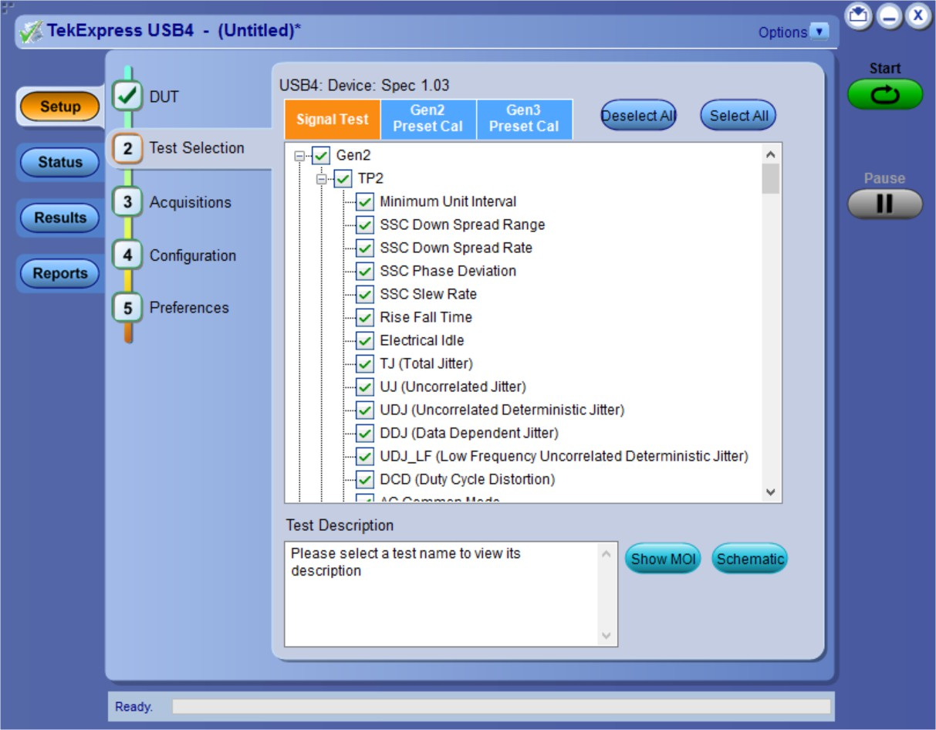

*Figure 7: Test selection tab*

###### Table 10: Test Selection tab configuration

|  |  |
| --- | --- |
| **Setting** | **Description** |
| **Deselect All, Select All** | Deselect or select all tests in the list. |
| Tests | Click a test to select or deselect. Selecting a test also show details about that test in the Test Description pane.  All required tests are selected when in Compliance test mode.  **Note:** The signal test 'Frequency Variation Training' is only available when DUT with Re-Timer is checked in DUT panel. |
| **Schematic** | Displays equipment connection setup for the selected measurements. You need to select at least a measurement before you click the Schematic. |
| Show MOI | Displays the MOI (USB4 DPOJET MOI) |
| Gen2 Preset Test | Select to change the preset values. By selecting or deselecting Legacy or Rounded column header, you can select or deselect all the presets at a single time for the selected data rate, when the Preset calibration in the DUT panel is selected. |
| Gen3 Preset Test |

**Note:** All tests are selected by default (except TJ using SQ2 when Test method is set to DPOJET).

**Note:** The application does not show the oscilloscope cursor1 and 2 for each burst. The application runs an analysis on the first five bursts of an acquisition and displays the result statistics.

**Note:** TJ using SQ2 measurement is not available when Test Method is set to SigTest in the DUT panel.

## Acquisitions: Set waveform acquisition settings

Use Acquisitions tab to view the test acquisition parameters. The contents displayed on this tab depends on the DUT type and the tests selected.

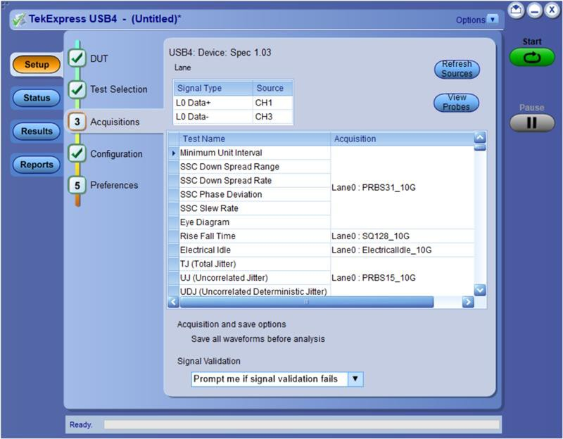

*Figure 8: Acquisition tab*

**Note:** USB4 acquires all waveforms required by each test group and generation being tested (Gen1, Gen2) before performing analysis.

###### Table 11: Acquisitions tab configuration

|  |  |
| --- | --- |
| **Setting** | **Description** |
| Source Selection | Lists the signal type and input channel assigned to that type. Click on Source fields to assign a channel source to a signal type.  The (Source) channels are auto selected, based on the probe type used and Lane selected on the DUT tab.  **Note:** When the **Test Method** is set to **SigTest** in the DUT panel, the application will not allow you to select the source channels. |
| Refresh sources | Updates the list of available channel sources as used by the Source fields in the Device list. Click this button if you want to change the channel connections in the test setup. |
| View Probes | Displays the Source, Probe Type, and Probe models. |
| Acquisition and save options | Saves all waveforms before the analysis. |
| Table continued… | |

|  |  |
| --- | --- |
| **Setting** | **Description** |
| Signal Validation | Sets the signal validation actions. Select from the available list items.   * Prompt me if signal fails * Skip test if signal validation fails * Use signal as is - Don't Check   When the signal validation option is set to "Prompt me if signal validation fails", the application validates whether the signal is PRBS31, PRBS15, SQ128, or SQ2 pattern. Additionally, it also validates if the signal is Electrical idle. If the signal is valid, the measurement continues normally. If the signal is invalid, the following window displays:    **Note:** If Pattern type validation is selected as **No**, then the measurement continues with the acquired waveform.   * Click **Reacquire** to start the acquisition again.  * Click **Use Anyway** to continue with the currently acquired waveform. * Click **Skip Test** to skip all pattern type tests. The rest of the selected measurements continue. |

TekExpress USB4 application saves all acquisition waveforms to files by default. Waveforms are saved in a unique folder for

each session (a session is started when you click the Start button). The folder path is X:\TekExpress USB4\Untitled Session\<dutid>\<date>_<time>. Images created for each analysis, XML files with result values, reports, and other information specific to that particular execution are also saved in this folder.

Saving a session moves the session file contents from the Untitled Session folder to the specified folder name and changes the session name to the specified name.

### Running tests on prerecorded (saved) waveforms

To load a saved waveform file:

1. Click **DUT**.
2. Click Use pre-recorded waveform files.
3. Click **Acquisitions**. The Waveform File Name column now shows browse buttons.

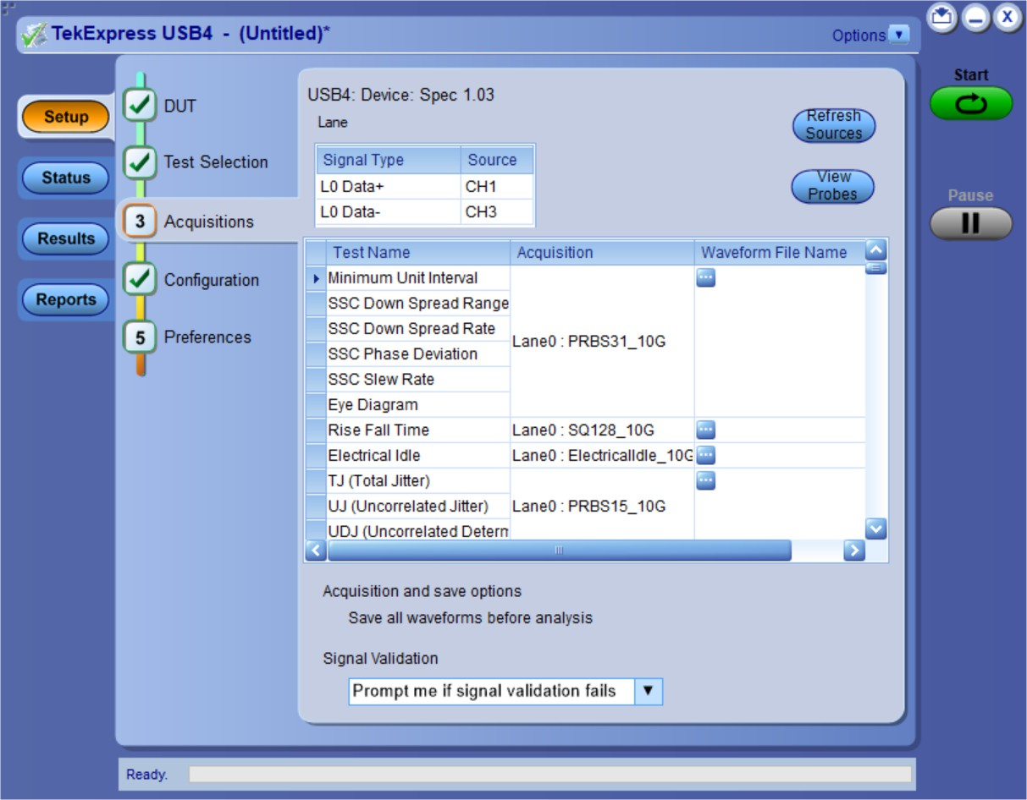

1. Click the browse button ( ) for each test acquisition type PRBS15, PRBS31, SQ128, and SQ2.
2. Navigate to and select the appropriate waveform file(s). You must select all waveforms required for the acquisition type.
3. To change, remove, or add a file to the list, click the browse button next to the file name to change, and use the menu items to replace, remove (delete) or add a file in the list.
4. Click **Start**.

## Configuration: Set measurement limits for tests

Use Configuration tab to view and configure the Global Settings and the measurement configurations. The measurement specific configurations available in this tab depends on the selections made in the DUT panel and Test Selection panel.

 **Note:** You cannot change test parameters that are grayed out.

###### Table 12: Configuration tab: Common parameters

|  |  |
| --- | --- |
| **Settings** | **Description** |
| Limit Editor | Displays the upper and lower limits for the applicable measurement using different types of comparisons. |

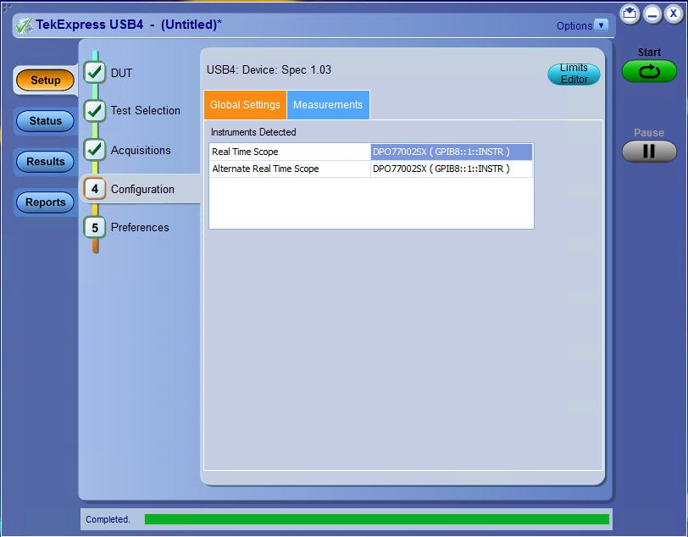

*Figure 9: Configuration tab: Global Settings*

###### Table 13: Configuration tab: Global Settings configuration

|  |  |
| --- | --- |
| **Setting** | **Description** |
| Instruments Detected | Displays a list of the connected instruments found during the instrument discovery. Instrument types includes oscilloscopes. Select **Options > Instrument Control Settings** to refresh the connected instrument list. Refer *TekExpress Instrument control settings.* |

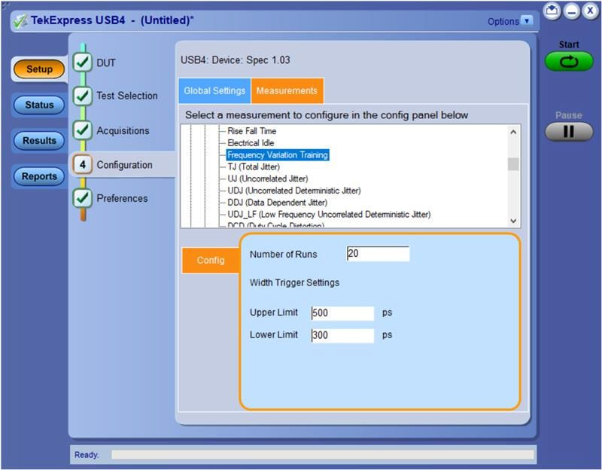

*Figure 10: Configuration tab: Measurement*

###### Table 14: Configuration tab: Measurements configuration

|  |  |
| --- | --- |
| **Setting** | **Description** |
| **Measurements** |  |
| Measurements | Displays the list of measurements. |
| Config | Select the configuration for the measurements with TP3. |
| Gen2 and Gen3 CTLE | Select the CTLE filter file for Gen2 and Gen3 from the drop-down:   * Optimize * Fixed   **Note:** The option **Fixed** is not available when the **Test Method** is set to  **SigTest** in the DUT panel. |
| CTLE Index | Set the CTLE index value. |
| Perform with DFE (Max Tap Value: 50 mV) | Select to perform the DFE. |

## Preferences: Set the test run preferences

Use **Preferences** tab to set the application action on completion of a measurement. The **Preferences** tab has the feature to enable or disable certain options related to the measurement execution.

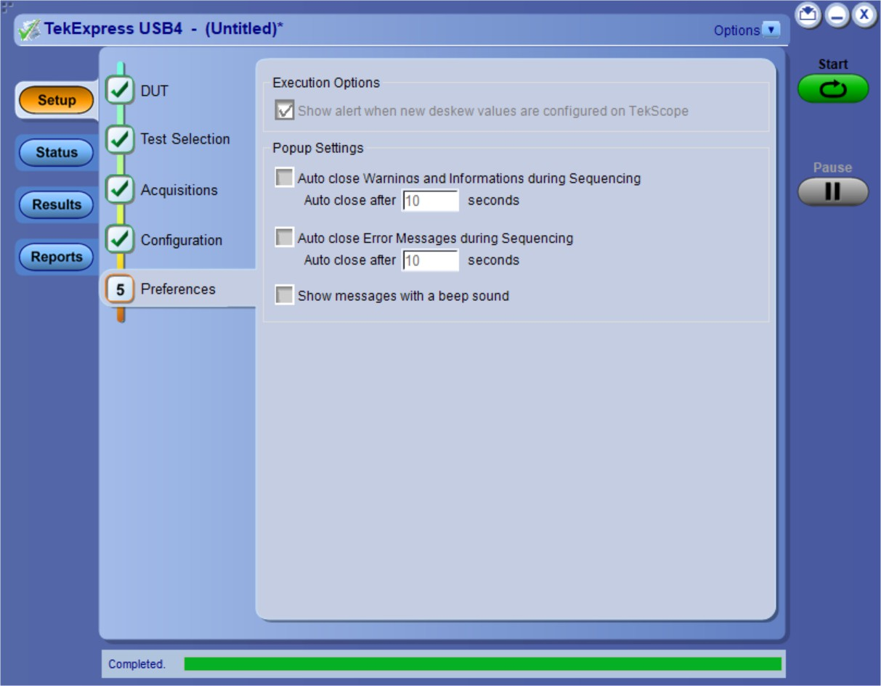

*Figure 11: Preferences tab*

Refer the below table for the options available in the **Preferences** tab:

###### Table 15: Preferences tab settings

|  |  |
| --- | --- |
| **Setting** | **Description** |
| **Execution Options** | |
| Show alert when new deskew values are configured on TekScope | Select to display the alert when new deskew values are configured on TekScope. |
| **Popup Settings** | |
| Auto close Warnings and informations during Sequencing Auto close after <no> seconds | Select to close the warnings and information window automatically after the specified amount of time.  Specify the time in seconds using the edit box. |
| Auto close Error Messages during Sequencing. Show in Reports Auto close after <no> seconds | Select to close the error message window automatically after the specified amount of time.  Specify the time in seconds using the edit box. |
| Show messages with a beep sound | Select to display the messages with the beep sound. |

# Status panel: View the test execution status

The Status panel contains the **Test Status** and **Log View** tabs, which provides status on the test acquisition and analysis (Test Status) and listing of test tasks performed (Log View tab). The application opens the **Test Status** tab when you start to execute the test. Select the **Test Status** or the **Log View** tab to view these items while the test execution is in progress.

## View test execution status

The tests are grouped and displayed based on the Clock and Data lane. It displays the tests along with the acquisition type, acquire, and analysis status of the tests. In pre-recorded mode, **Acquire Status** is not valid.

The **Test Status** tab presents a collapsible table with information about each test as it is running. Use the symbols to expand () and collapse () the table rows.

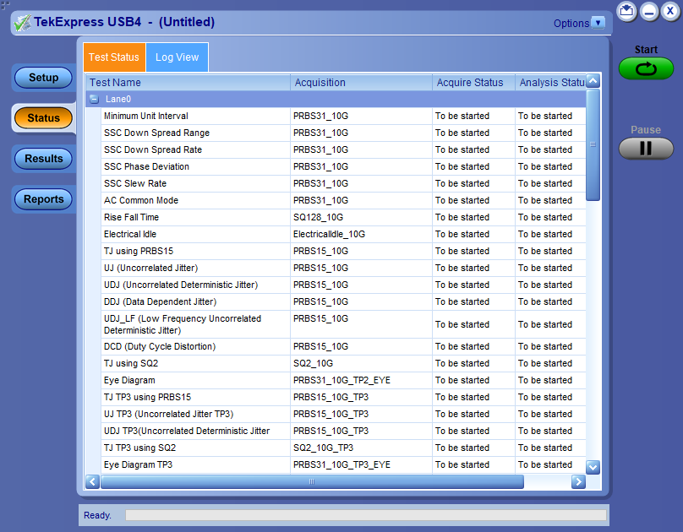

*Figure 12: Test execution status view in Status panel*

###### Table 16: Test execution status table headers

|  |  |
| --- | --- |
| **Control** | **Description** |
| Test Name | Displays the measurement name. |
| Acquisition | Describes the type of data being acquired. |
| Acquire Status | Displays the progress state of the acquisition:   * To be started * In Progress * Completed Acquisition |
| Table continued… | |

|  |  |
| --- | --- |
| **Control** | **Description** |
| Analysis Status | Displays the progress state of the analysis:   * To be started * In Progress * Completed * Stopped |

## View test execution logs

The Test Status tab displays the detailed execution status of the tests. Also, displays each and every execution step in detail with its timestamp information. The log details can be used to troubleshoot and resolve any issue/bug which is blocking the test execution process.

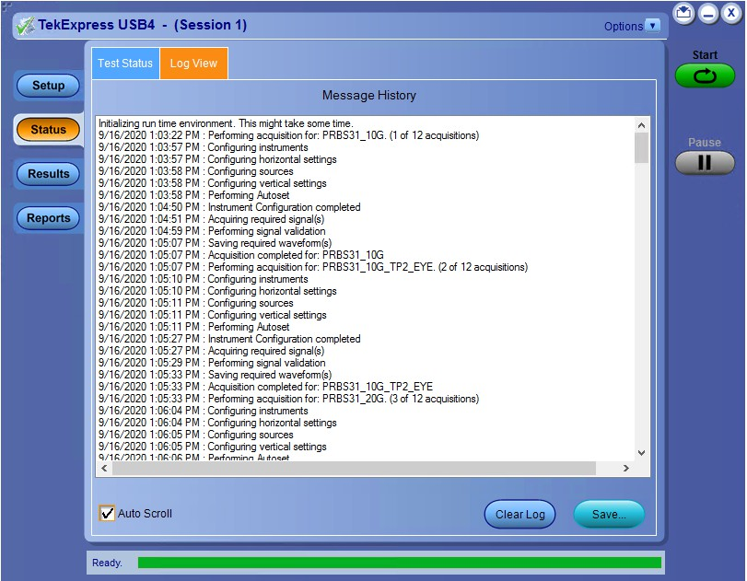

*Figure 13: Log view in Status panel*

###### Table 17: Status panel settings

|  |  |
| --- | --- |
| **Control** | **Description** |
| Message History | Lists all the executed test operations and timestamp information. |
| Auto Scroll | Enables automatic scrolling of the log view as information is added to the log during the test execution. |
| Clear Log | Clears all the messages from the log view. |
| Save | Saves the log file into a text file format. Use the standard Save File window to navigate to and specify the folder and file name to save the log text. |

# Results panel: View summary of test results

When a test execution is complete, the application automatically opens the **Results** panel to display a summary of test results.

In the Results table, each test result occupies a row. By default, results are displayed in summary format with the measurement details collapsed and with the Pass/Fail column visible.

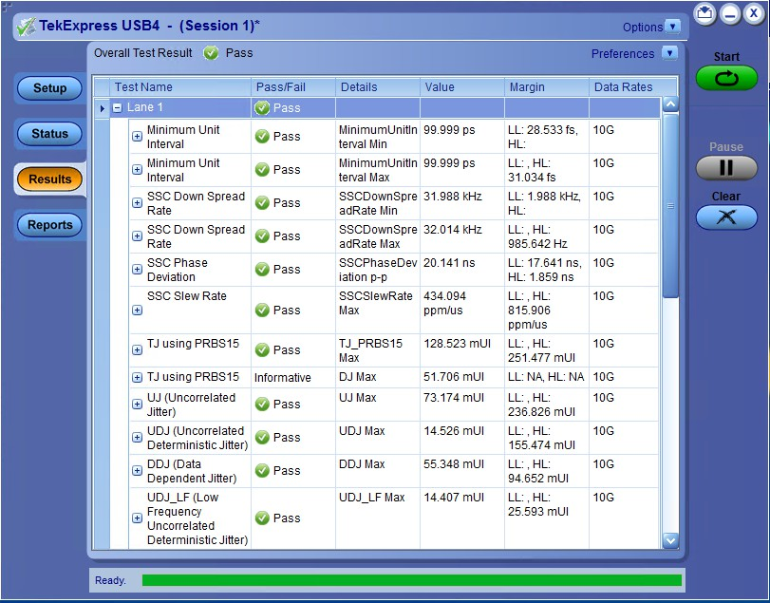

*Figure 14: Results panel with measurement results*

Click  icon on each measurement in the row to expand and to display the minimum and maximum parameter values of the measurement.

## Filter the test results

Each column in the result table can be customized and displayed by enabling or disabling any column as per your requirement. You can change the view in the following ways:

* To remove or restore the Pass/Fail column, select **Preferences** > **Show Pass/Fail**.
* To collapse all expanded tests, select **Preferences** > **View Results Summary**.
* To expand all the listed tests, select **View Results Details** from the **Preferences menu** in the upper right corner.
* To enable or disable the wordwrap feature, select **Preferences** > **Enable Wordwrap**.
* To view the results grouped by lane or test, select the corresponding item from the **Preferences** menu.
* To expand the width of a column, place the cursor over the vertical line that separates the column from the column to the right. When the cursor changes to a double-ended arrow, hold down the mouse button and drag the column to the desired width.
* To clear all test results displayed, click **Clear**.

# Reports panel: Configure report generation settings

Click **Reports** panel to configure the report generation settings and select the test result information to include in the report. You can use the Reports panel to configure report generation settings, select test content to include in reports, generate the report, view the report, browse for reports, name and save reports, and select report viewing options.

## Report configuration settings

The Configuration tab describes the report generation settings to configure the Reports panel. Select report settings before running a test or when creating and saving test setups. Report settings configured are included in saved test setups.

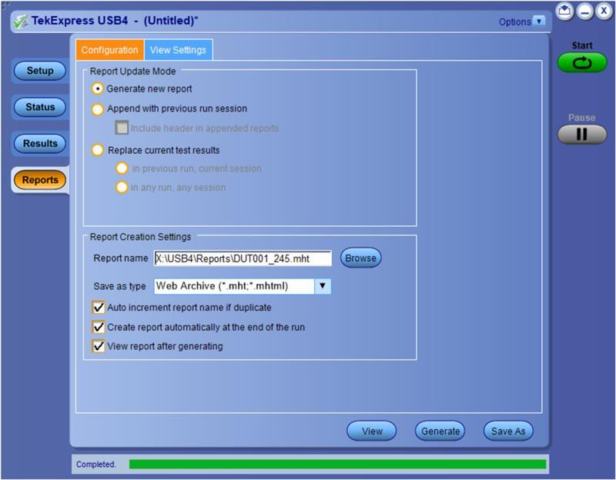

*Figure 15: Report panel- Configuration tab*

###### Table 18: Report configuration panel settings

|  |  |
| --- | --- |
| **Control** | **Description** |
| View | Click to view the most current report. |
| Generate Report | Generates a new report based on the current analysis results. |
| Save As | Specify a name for the report. |
| **Report Update Mode Settings** | |
| Generate new report | Each time when you click **Run** and when the test execution is complete, it will create a new report. The report can be in either .mht, .pdf, or .csv file formats. |
| Append with previous run session | Appends the latest test results to the end of the current test results report. Each time when you click this option and run the tests, it will run the previously failed tests and replace the failed test result with the new pass test result in the same report. |
| Table continued… | |

|  |  |
| --- | --- |
| **Control** | **Description** |
| Include header in appended reports | Select to include header in appended reports. |
| Replace current test results | Replaces the previous test results with the latest test results. Results from newly added tests are appended to the end of the report. |
| In previous run, current session | Select to replace current test results in the report with the test result(s) of previous run in the current session. |
| In any run, any session | Select to replace current test results in the report with the test result(s) in the selected run session’s report. Click and select test result of any other run session. |
| **Report Creation Settings** | |
| Report name | Displays the name and path of the <Application Name> report. The default location is at \My Documents>\My TekExpress\<Application  Name>\Reports. The report file in this folder gets overwritten each time you run a test unless you specify a unique name or select to auto increment the report name.  **To change the report name or location, do one of the following:**   * In the Report Path field, type the current folder path and name. * Double-click in the Report Path field and then make selections from the popup keyboard and click **Enter**.   Be sure to include the entire folder path, the file name, and the file extension.  For example: C:\Documents and Settings\your user name\My Documents\My TekExpress\<Application Name> \DUT001.mht.  **Note:** You cannot set the file location using the Browse button.  **Open an existing report**  Click **Browse**, locate and select the report file and then click **View** at the bottom of the panel. |
| Save as type | Saves a report in the specified file type, selected from the drop-down list. The report is saved in .csv, .pdf, or .mht.  **Note:**  If you select a file type different from the default, be sure to change the report file name extension in the Report Name field to match. |
| Auto increment report name if duplicate | Sets the application to automatically increment the name of the report file if the application finds a file with the same name as the one being generated. For example: DUT001, DUT002, DUT003. This option is enabled by default. |
| Create report automatically at the end of the run | Select to create the report with the settings configured, at the end of run. |
| View report after generating | Automatically opens the report in a Web browser when the test execution is complete. This option is selected by default. |

## Configure report view settings

The **View Settings** tab describes the report view settings to configure the Reports panel. Select report view settings before running a test or when creating and saving test setups. Report settings configured are included in saved test setups.

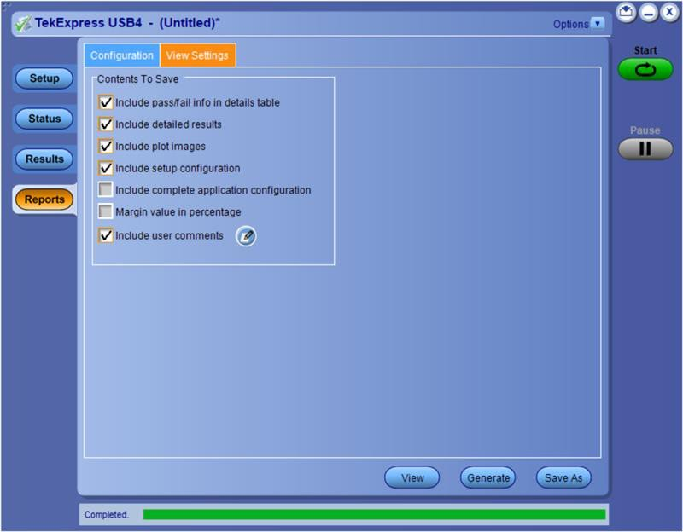

*Figure 16: Report panel-View settings tab*

###### Table 19: Report panel view settings

|  |  |
| --- | --- |
| **Control** | **Description** |
| **Contents To Save Settings** | |
| Include pass/fail info in details table | Select to include pass/fail information in the details table of the report. |
| Include detailed results | Select to include detailed results in the report. |
| Include plot images | Select to include the plot images in the report. |
| Include setup configuration | Sets the application to include hardware and software information in the summary box at the top of the report. Information includes: the oscilloscope model and serial number, the oscilloscope firmware version, and software versions for applications used in the measurements. |
| Include complete application configuration | Select to include the complete application configuration in the report. |
| Margin value in percentage |  |
| Include user comments | Select to include any comments about the test that you or another user have added in the DUT tab of the Setup panel. Comments appear in the Comments section, below the summary box at the beginning of each report. |

## View a generated report

Sample report and its contents

A report shows detailed results and plots, as set in the Reports panel.

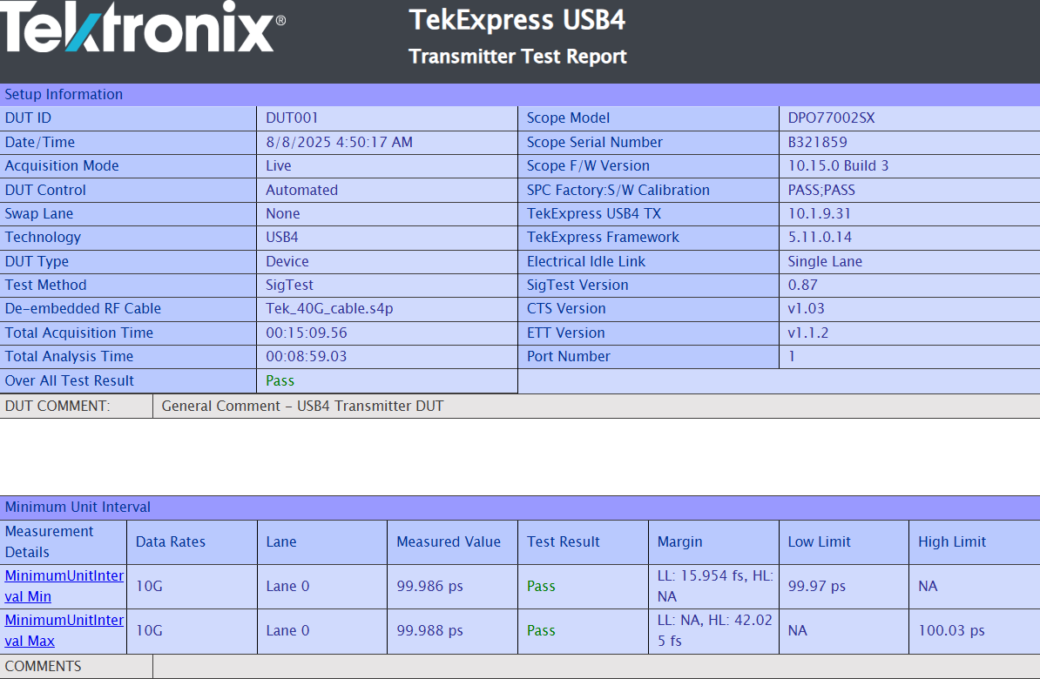

*Figure 17: Report*

**Setup Information** The summary box at the beginning of the report lists setup configuration information. This information includes the oscilloscope model and serial number, optical module model and serial number, and software version numbers of all associated applications.

**Test Name Summary Table** The test summary table lists all the tests which are executed with its result status.

**Measurement** The measurement table displays the measurement related details with its parameter value.

**User comments** If you had selected to include comments in the test report, any comments you added in the DUT tab are shown at the top of the report.

# Saving and recalling test setup

## Overview

You can save the test setup and recall it later for further analysis. Saved setup includes the selected oscilloscope, general parameters, acquisition parameters, measurement limits, waveforms (if applicable), and other configuration settings. The setup files are saved under the setup name at **X:\USB4**

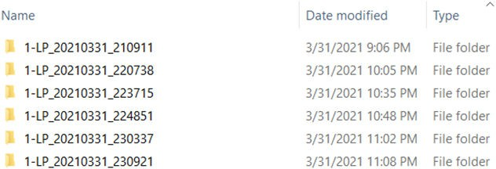

*Figure 18: Example of Test Setup File*

Use test setups to:

* Recall a saved configuration.
* Run a new session or acquire live waveforms.
* Create a new test setup using an existing one.
* View all the information associated with a saved test, including the log file, the history of the test status as it executed, and the results summary.
* Run a saved test using saved waveforms.

**Note:** Images that are shown in this Saving and recalling test setup chapter are for illustration purpose only and it may vary depending on the TekExpress application.

## Save the configured test setup

You can save a test setup before or after running a test. You can create a test setup from already created test setup or using a default test setup. When you save a setup, all the parameters, measurement limits, waveform files (if applicable), test selections, and other configuration settings are saved under the setup name. When you select the default test setup, the parameters are set to the application’s default value.

* Select **Options > Save Test Setup** to save the opened setup.

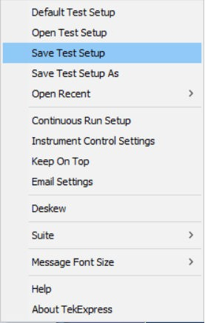

* 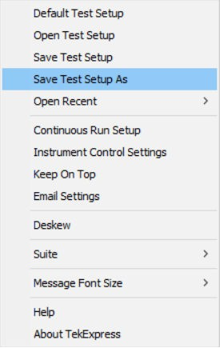Select **Options > Save Test Setup As** to save the setup with different name.

## Load a saved test setup

To open (load) a saved test setup, do the following:

* Select **Options > Open Test Setup**.

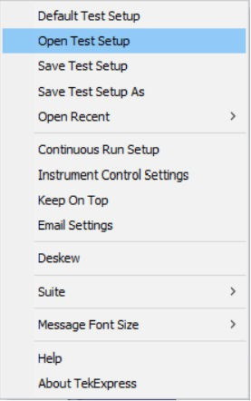

* 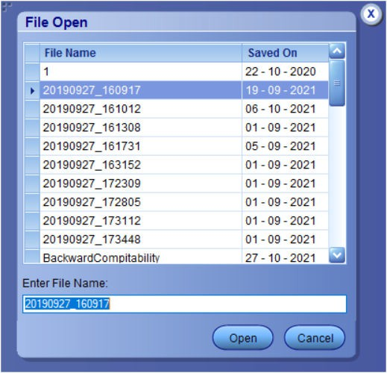From the **File Open** menu, select the setup file name from the list and click **Open**.

 **Note:** Parameters that are set for the respective test setup will enable after opening the file.

## Perform a test using pre-run session files

Complete the following steps to load a test setup from a pre-run session:

1. Select **Options > Open Test Setup**.



1. From the **File Open** menu, select a setup from the list and then click **Open**.

 **Note:** Parameters that are set for the respective test setup will enable after opening the file.

1. Switch the mode to **Use Pre-recorded waveform files** in the DUT panel.



1. Select the required waveforms from the selected setup in the **Acquisitions** tab and click **Start**.
2. The selected waveform file can be removed/replaced by clicking on the () icon.



1. 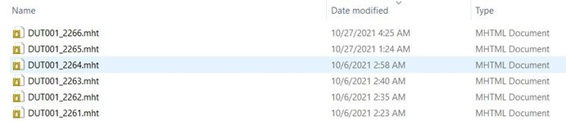After successful completion of the test, the waveform report files are stored at X:\<Application Name>\Reports.
2. The overall test result status after completion of the test execution is displayed in the Results Panel.



## Save the test setup with a different name

To save a test setup with a different name, follow the steps:

1. Select **Options > Save Test Setup As**.
2. Enter the new test setup name and click **Save**.

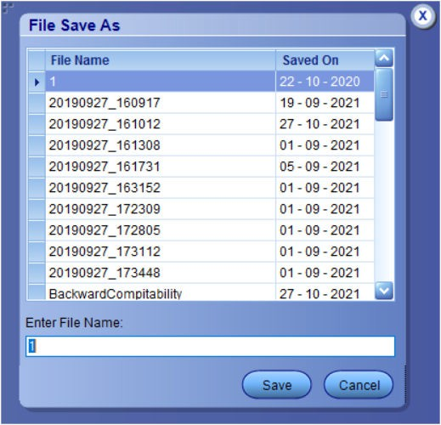

# SCPI Commands

## About SCPI command

You can use the Standard Commands for Programmable Instruments (SCPI) to communicate remotely with the TekExpress application. Complete the TCPIP socket configuration and the TekVISA configuration in the oscilloscope or in the device where you are executing the script.

**Note:** If you are using an external PC to execute the remote interface commands, then install TekVISA in the PC to make the configurations.

## Socket configuration for SCPI commands

This section describes the steps to configure the TCPIP socket configuration in your script execution device and the steps to configure the TekVISA configuration in the oscilloscope to execute the SCPI commands.

##### TCPIP socket configuration

1. 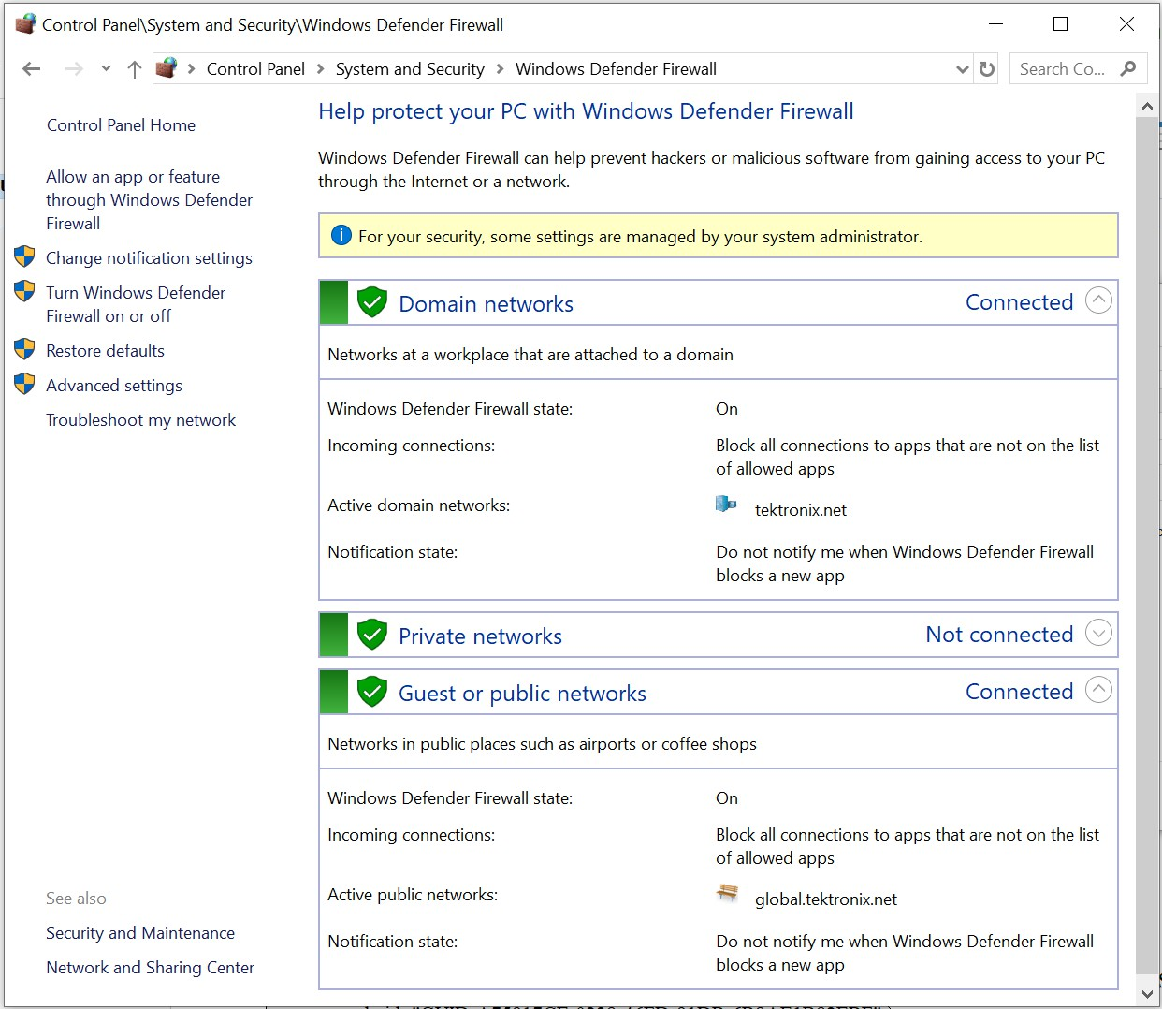Click Start > Control Panel > System and Security > Windows Firewall > Advanced settings.
2. In Windows Firewall with Advanced Security menu, select **Windows Firewall with Advanced Security on Local Computer** >

**Inbound Rules** and click **New Rule…**

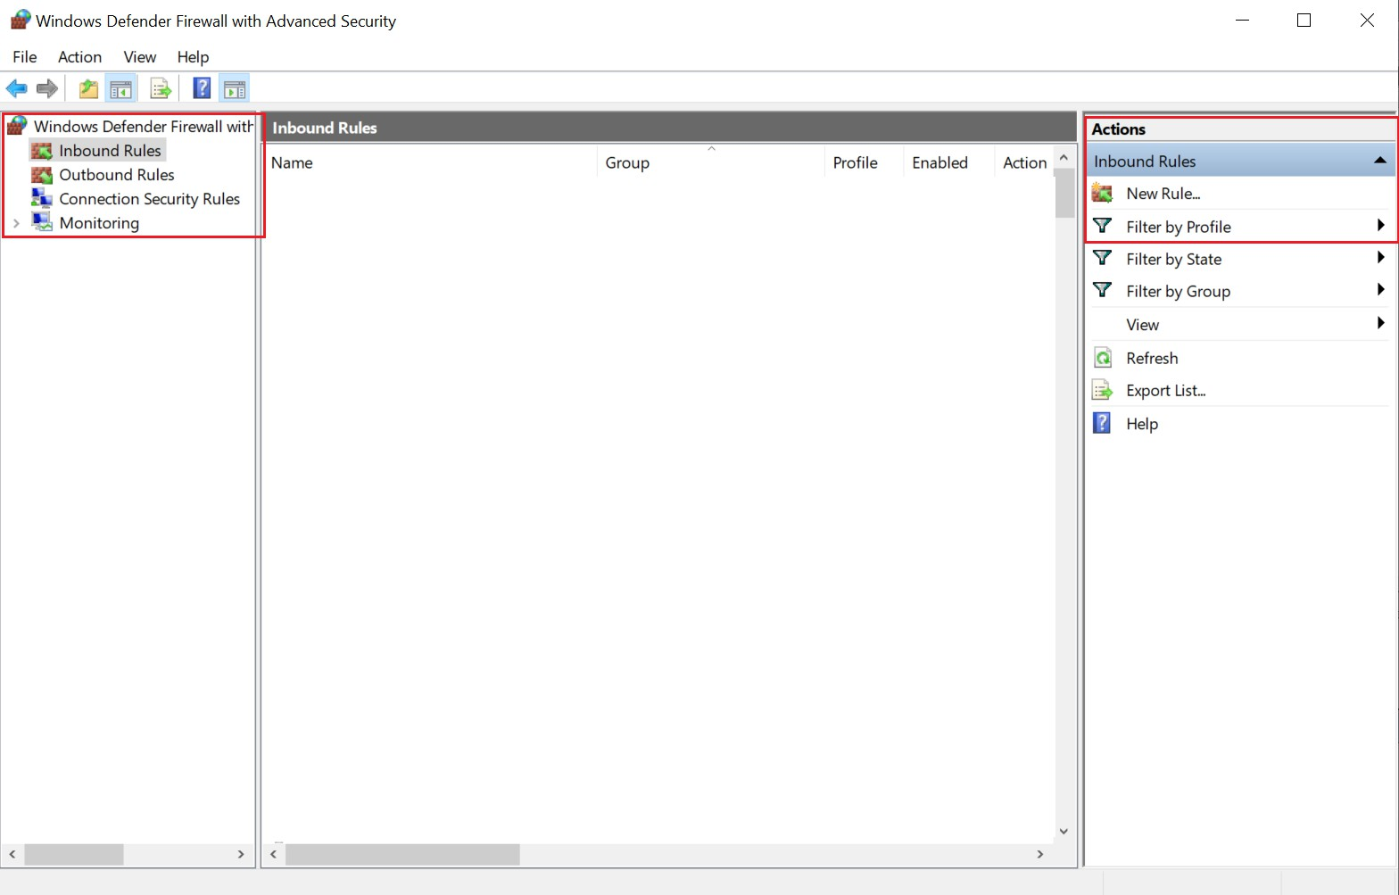

1. In **New Inbound Rule Wizard** menu
   1. Select **Port** and click **Next**.

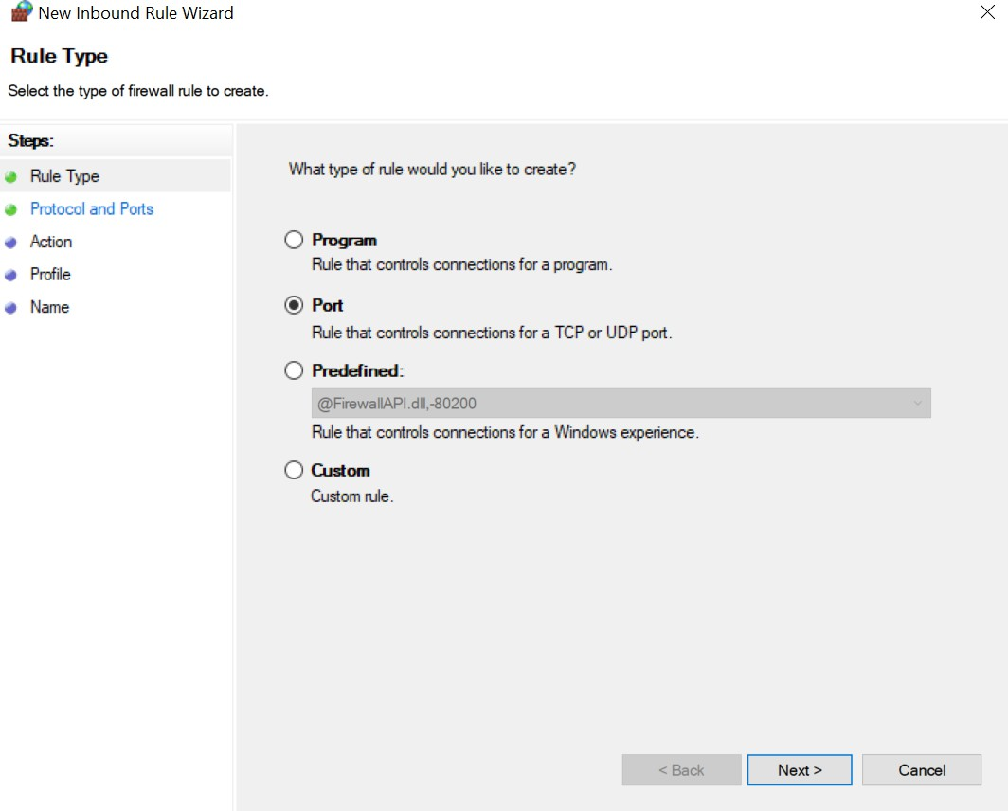

* 1. Select **TCP** as rule apply, enter 5000 for **Specific local ports** and click **Next**.

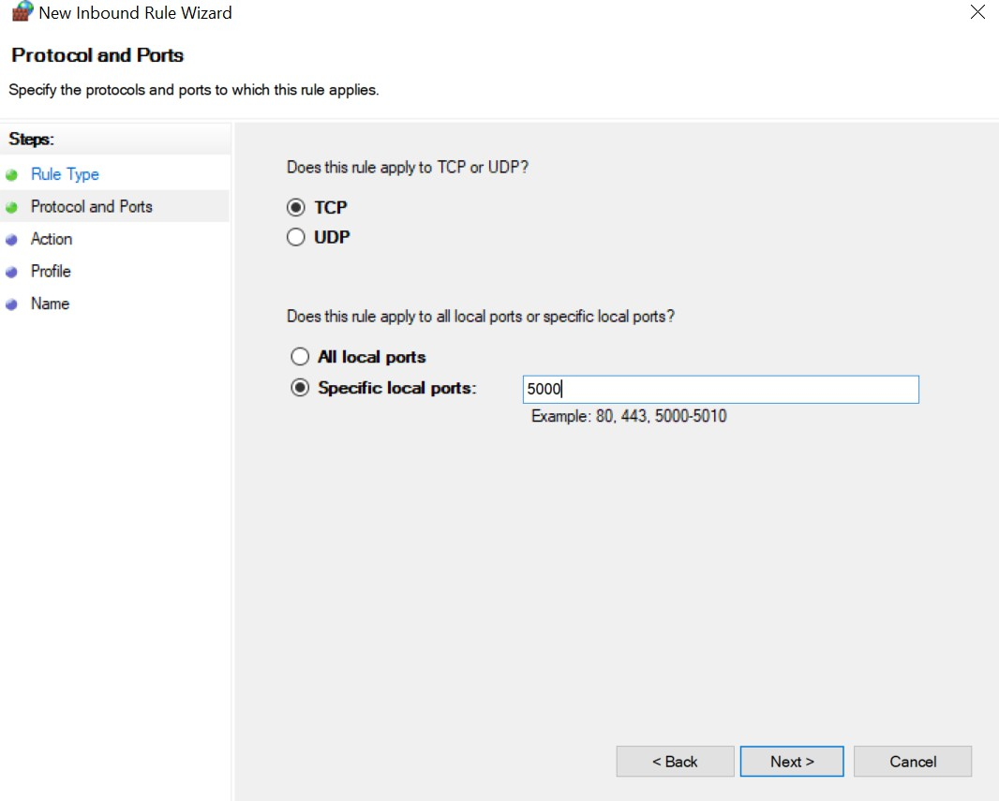

* 1. Select **Allow the connection** and click **Next**.

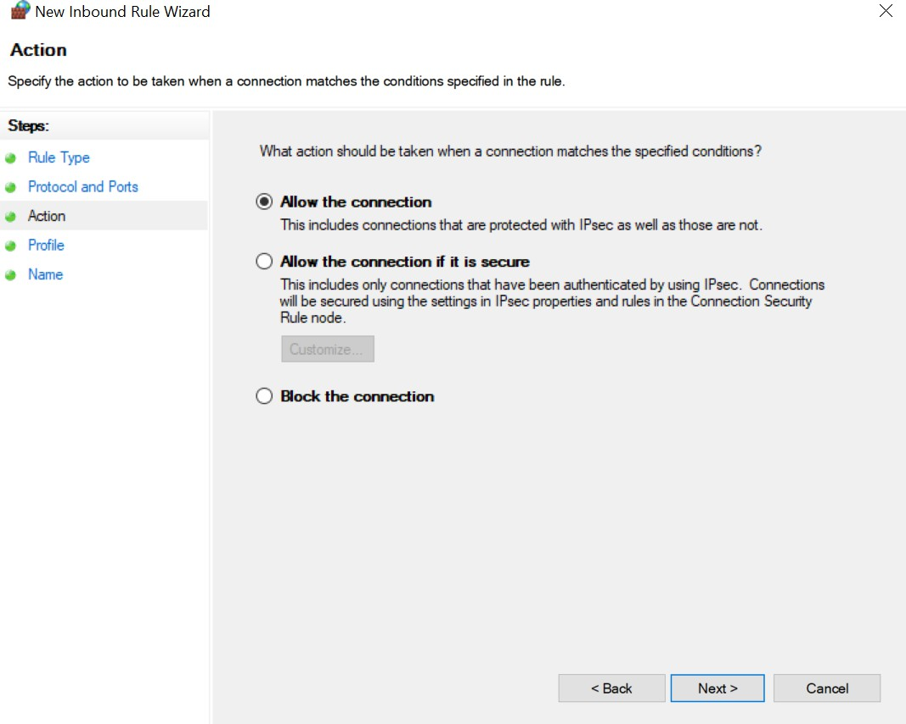

* 1. Select **Domain, Private, Public** checkbox and click **Next**.

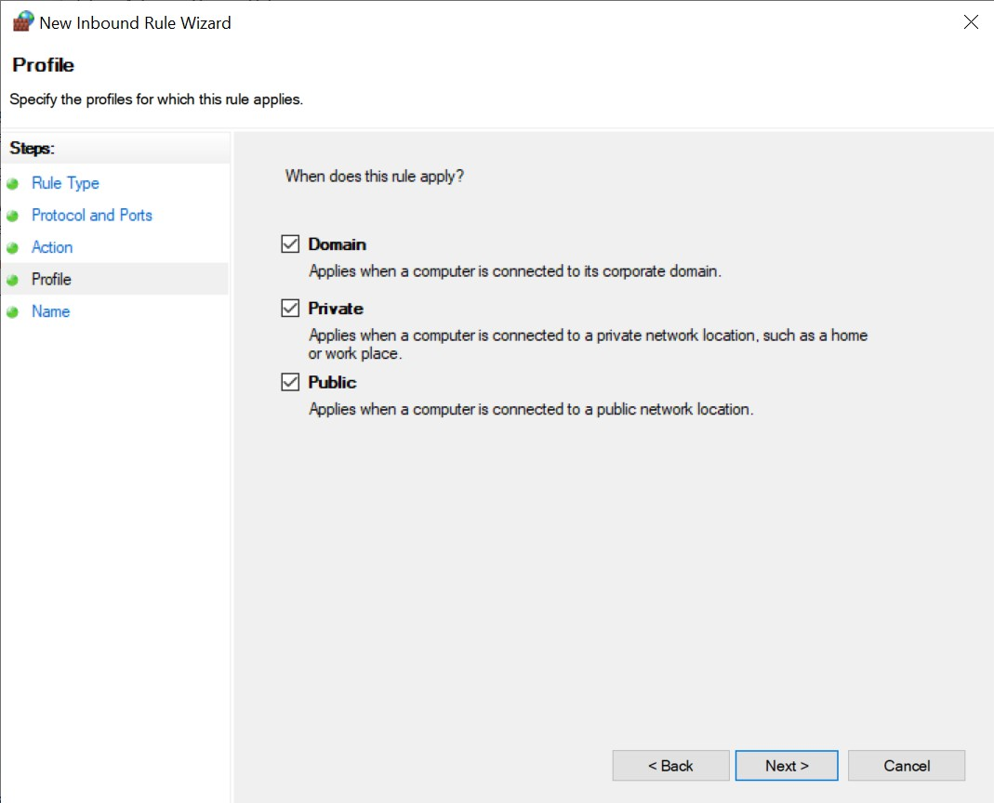

* 1. Enter **Name**, Description (optional), and click **Finish**.

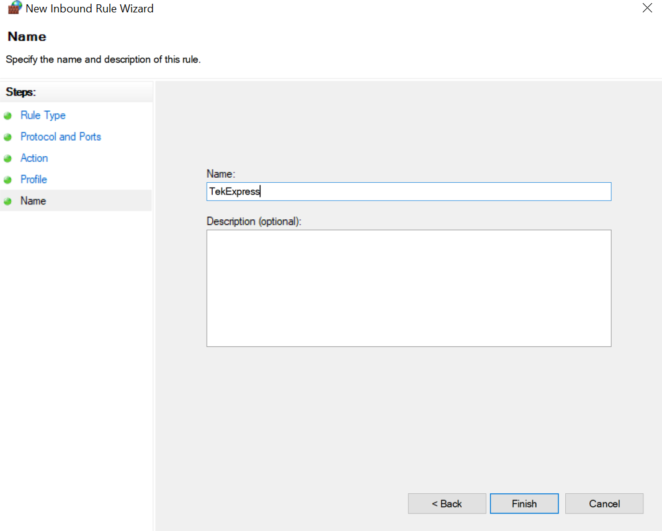

1. Check whether the Rule name is displayed in **Windows Firewall with Advanced Security menu** > **Inbound Rules**.

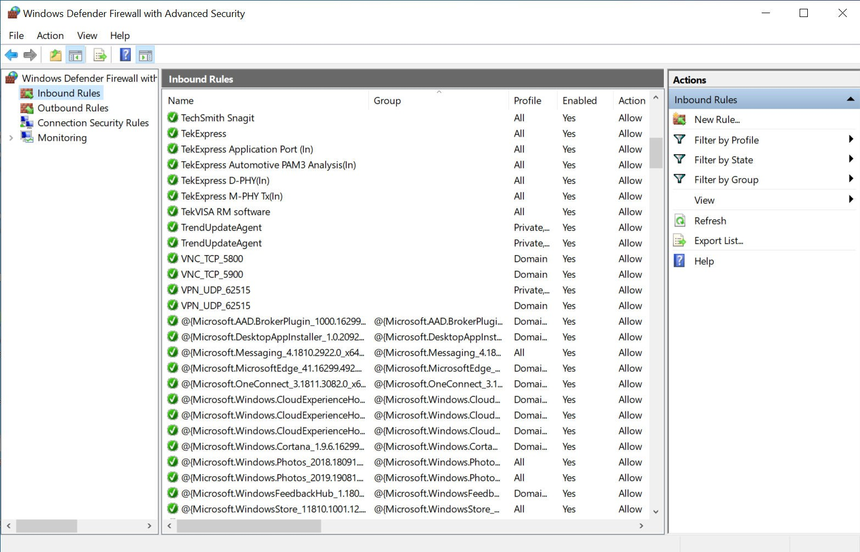

##### TekVISA configuration

1. Click Start > All Programs > TekVISA > OpenChoice Instrument Manager.

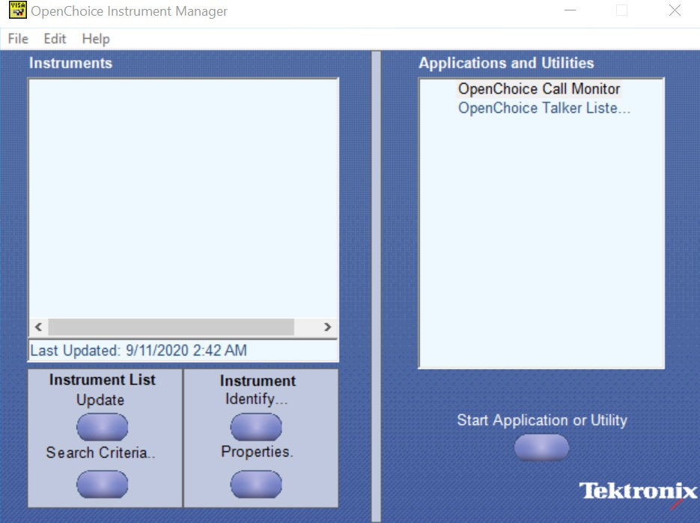

1. Click **Search Criteria**. In **Search Criteria** menu, click **LAN** to Turn-on. Select **Socket** from the drop-down list, enter the IP address of the TekExpress device in **Hostname** and type **Port** as 5000. Click  to configure the IP address with Port.

Enter the Hostname as 127.0.0.1 if the TekVISA and TekExpress application are in the same system, else enter the IP address of the oscilloscope where the TekExpress application is running.

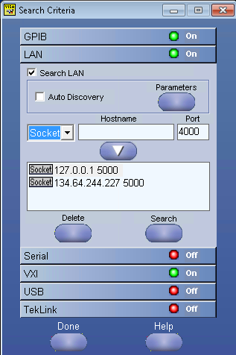

1. 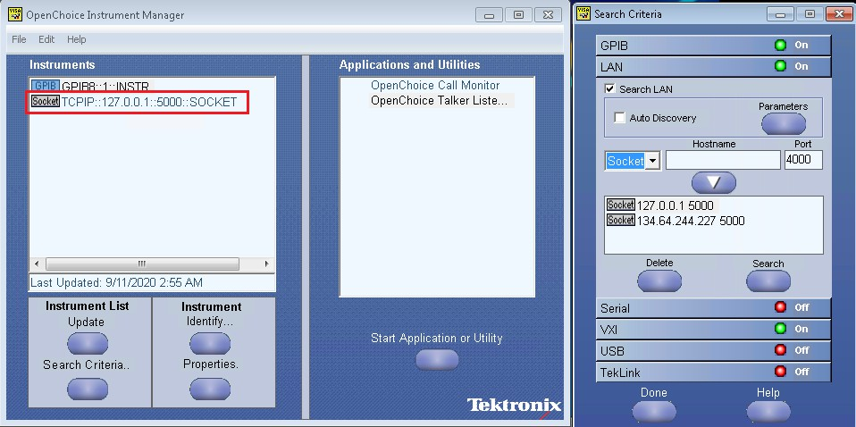Click **Search** to setup the TCPIP connection with the host. Check whether the TCPIP host name is displayed in **OpenChoice Instrument Manager** > **Instruments**.
2. Double-click **OpenChoice Talker Listener** and enter the Command *IDN? in command entry field and click **Query**. Check that the Operation is successful and Talker Listener Readout displays the Command / Data.

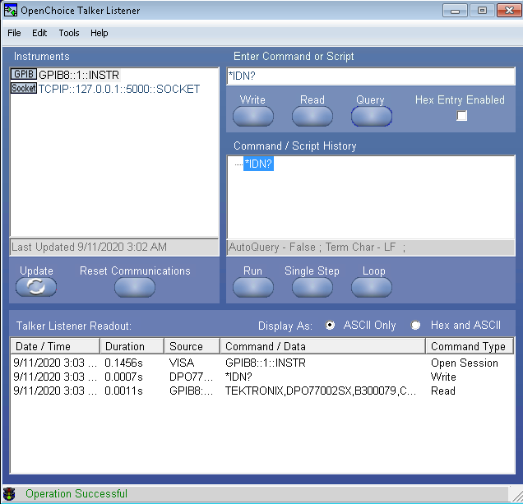

## Set or query the device name of application

This command sets or queries the device name of the application.

##### Syntax

TEKEXP:SELECT DEVICE,"<DeviceName>" (Set)

TEKEXP:SELECT? DEVICE (Query)

##### Command arguments

|  |  |
| --- | --- |
| **Argument Name** | **Argument Type** |
| <DeviceName> | <String> |

##### Returns

<String>

##### Examples

TEKEXP:SELECT DEVICE,"<DeviceName>" command sets the device name of the application.

TEKEXP:SELECT? DEVICE command returns the selected device name of the application.

## Set or query the suite name of the application

This command sets or queries the suite name of the application.

##### Syntax

TEKEXP:SELECT SUITE,"<SuiteName>" (Set)

TEKEXP:SELECT? SUITE (Query)

##### Command arguments

|  |
| --- |
| **SuiteName** |
| Device |
| Hose |

##### Returns

<String>

##### Examples

TEKEXP:SELECT SUITE,"<SuiteName>" command sets the suite name of the application.

TEKEXP:SELECT? SUITE command returns the selected suite of the application.

## Set or query the test name of the application

This command selects or deselects the specified test name of the application.

##### Syntax

TEKEXP:SELECT TEST,"<TestName>",<Value> (Set)

TEKEXP:SELECT? TEST (Query)

##### Command arguments

|  |  |
| --- | --- |
| **TestName** | **Value** |
| AC Common Mode 10G | * Included * Excluded |
| AC Common Mode 10p3G | * Included * Excluded |
| AC Common Mode 20G | * Included * Excluded |
| AC Common Mode 20p6G | * Included * Excluded |
| Average Unit Interval 10p3G | * Included * Excluded |
| Table continued… | |

|  |  |
| --- | --- |
| **TestName** | **Value** |
| DDJ (Data Dependent Jitter) 10G | * Included * Excluded |
| DDJ (Data Dependent Jitter) 10p3G | * Included * Excluded |
| DDJ (Data Dependent Jitter) 20G | * Included * Excluded |
| DDJ (Data Dependent Jitter) 20p6G | * Included * Excluded |
| Duty Cycle Distortion 10G | * Included * Excluded |
| Duty Cycle Distortion 10p3G | * Included * Excluded |
| Duty Cycle Distortion 20G | * Included * Excluded |
| Duty Cycle Distortion 20p6G | * Included * Excluded |
| Electrical Idle 10G | * Included * Excluded |
| Electrical Idle 10p3G | * Included * Excluded |
| Electrical Idle 20G | * Included * Excluded |
| Electrical Idle 20p6G | * Included * Excluded |
| Eye Diagram TP2 10G | * Included * Excluded |
| Eye Diagram TP2 10p3G | * Included * Excluded |
| Eye Diagram TP2 20G | * Included * Excluded |
| Table continued… | |

|  |  |
| --- | --- |
| **TestName** | **Value** |
| Eye Diagram TP2 20p6G | * Included * Excluded |
| Eye Diagram TP3 10G | * Included * Excluded |
| Eye Diagram TP3 10p3G | * Included * Excluded |
| Eye Diagram TP3 20G | * Included * Excluded |
| Eye Diagram TP3 20p6G | * Included * Excluded |
| Frequency Variation Training 10G | * Included * Excluded |
| Frequency Variation Training 20G | * Included * Excluded |
| Minimum Unit Interval 10G | * Included * Excluded |
| Minimum Unit Interval 10p3G | * Included * Excluded |
| Minimum Unit Interval 20G | * Included * Excluded |
| Minimum Unit Interval 20p6G | * Included * Excluded |
| Preset0 10G | * Included * Excluded |
| Preset0 10p3G | * Included * Excluded |
| Preset0 20G | * Included * Excluded |
| Preset0 20p6G | * Included * Excluded |
| Table continued… | |

|  |  |
| --- | --- |
| **TestName** | **Value** |
| Preset1 10G | * Included * Excluded |
| Preset1 10p3G | * Included * Excluded |
| Preset1 20G | * Included * Excluded |
| Preset1 20p6G | * Included * Excluded |
| Preset2 10G | * Included * Excluded |
| Preset2 10p3G | * Included * Excluded |
| Preset2 20G | * Included * Excluded |
| Preset2 20p6G | * Included * Excluded |
| Preset3 10G | * Included * Excluded |
| Preset3 10p3G | * Included * Excluded |
| Preset3 20G | * Included * Excluded |
| Preset3 20p6G | * Included * Excluded |
| Preset4 10G | * Included * Excluded |
| Preset4 10p3G | * Included * Excluded |
| Preset4 20G | * Included * Excluded |
| Table continued… | |

|  |  |
| --- | --- |
| **TestName** | **Value** |
| Preset4 20p6G | * Included * Excluded |
| Preset5 10G | * Included * Excluded |
| Preset5 10p3G | * Included * Excluded |
| Preset5 20G | * Included * Excluded |
| Preset5 20p6G | * Included * Excluded |
| Preset6 10G | * Included * Excluded |
| Preset6 10p3G | * Included * Excluded |
| Preset6 20G | * Included * Excluded |
| Preset6 20p6G | * Included * Excluded |
| Preset7 10G | * Included * Excluded |
| Preset7 10p3G | * Included * Excluded |
| Preset7 20G | * Included * Excluded |
| Preset7 20p6G | * Included * Excluded |
| Preset8 10G | * Included * Excluded |
| Preset8 10p3G | * Included * Excluded |
| Table continued… | |

|  |  |
| --- | --- |
| **TestName** | **Value** |
| Preset8 20G | * Included * Excluded |
| Preset8 20p6G | * Included * Excluded |
| Preset9 10G | * Included * Excluded |
| Preset9 10p3G | * Included * Excluded |
| Preset9 20G | * Included * Excluded |
| Preset9 20p6G | * Included * Excluded |
| Preset10 10G | * Included * Excluded |
| Preset10 10p3G | * Included * Excluded |
| Preset10 20G | * Included * Excluded |
| Preset10 20p6G | * Included * Excluded |
| Preset11 10G | * Included * Excluded |
| Preset11 10p3G | * Included * Excluded |
| Preset11 20G | * Included * Excluded |
| Preset11 20p6G | * Included * Excluded |
| Preset12 10G | * Included * Excluded |
| Table continued… | |

|  |  |
| --- | --- |
| **TestName** | **Value** |
| Preset12 10p3G | * Included * Excluded |
| Preset12 20G | * Included * Excluded |
| Preset12 20p6G | * Included * Excluded |
| Preset13 10G | * Included * Excluded |
| Preset13 10p3G | * Included * Excluded |
| Preset13 20G | * Included * Excluded |
| Preset13 20p6G | * Included * Excluded |
| Preset14 10G | * Included * Excluded |
| Preset14 10p3G | * Included * Excluded |
| Preset14 20G | * Included * Excluded |
| Preset14 20p6G | * Included * Excluded |
| Preset15 10G | * Included * Excluded |
| Preset15 10p3G | * Included * Excluded |
| Preset15 20G | * Included * Excluded |
| Preset15 20p6G | * Included * Excluded |
| Table continued… | |

|  |  |
| --- | --- |
| **TestName** | **Value** |
| Rise Fall Time 10G | * Included * Excluded |
| Rise Fall Time 10p3G | * Included * Excluded |
| Rise Fall Time 20G | * Included * Excluded |
| Rise Fall Time 20p6G | * Included * Excluded |
| SSC Down Spread Range 10G | * Included * Excluded |
| SSC Down Spread Range 10p3G | * Included * Excluded |
| SSC Down Spread Range 20G | * Included * Excluded |
| SSC Down Spread Range 20p6G | * Included * Excluded |
| SSC Down Spread Rate 10G | * Included * Excluded |
| SSC Down Spread Rate 10p3G | * Included * Excluded |
| SSC Down Spread Rate 20G | * Included * Excluded |
| SSC Down Spread Rate 20p6G | * Included * Excluded |
| SSC Phase Deviation 10G | * Included * Excluded |
| SSC Phase Deviation 10p3G | * Included * Excluded |
| SSC Phase Deviation 20G | * Included * Excluded |
| Table continued… | |

|  |  |
| --- | --- |
| **TestName** | **Value** |
| SSC Phase Deviation 20p6G | * Included * Excluded |
| SSC Slew Rate 10G | * Included * Excluded |
| SSC Slew Rate 10p3G | * Included * Excluded |
| SSC Slew Rate 20G | * Included * Excluded |
| SSC Slew Rate 20p6G | * Included * Excluded |
| TJ (Total Jitter) 10G | * Included * Excluded |
| TJ (Total Jitter) 10p3G | * Included * Excluded |
| TJ (Total Jitter) 20G | * Included * Excluded |
| TJ (Total Jitter) 20p6G | * Included * Excluded |
| TJ (Total Jitter) TP3 10G | * Included * Excluded |
| TJ (Total Jitter) TP3 10p3G | * Included * Excluded |
| TJ (Total Jitter) TP3 20G | * Included * Excluded |
| TJ (Total Jitter) TP3 20p6G | * Included * Excluded |
| TJ TP3 using PRBS15 10G | * Included * Excluded |
| TJ TP3 using PRBS15 10p3G | * Included * Excluded |
| Table continued… | |

|  |  |
| --- | --- |
| **TestName** | **Value** |
| TJ TP3 using PRBS15 20G | * Included * Excluded |
| TJ TP3 using PRBS15 20p6G | * Included * Excluded |
| TJ TP3 using SQ2 10G | * Included * Excluded |
| TJ TP3 using SQ2 10p3G | * Included * Excluded |
| TJ TP3 using SQ2 20G | * Included * Excluded |
| TJ TP3 using SQ2 20p6G | * Included * Excluded |
| TJ using PRBS15 10G | * Included * Excluded |
| TJ using PRBS15 10p3G | * Included * Excluded |
| TJ using PRBS15 20G | * Included * Excluded |
| TJ using PRBS15 20p6G | * Included * Excluded |
| TJ using SQ2 10G | * Included * Excluded |
| TJ using SQ2 10p3G | * Included * Excluded |
| TJ using SQ2 20G | * Included * Excluded |
| TJ using SQ2 20p6G | * Included * Excluded |
| TXEQ Preset 0 10G | * Included * Excluded |
| Table continued… | |

|  |  |
| --- | --- |
| **TestName** | **Value** |
| TXEQ Preset 0 10p3G | * Included * Excluded |
| TXEQ Preset 0 20G | * Included * Excluded |
| TXEQ Preset 0 20p6G | * Included * Excluded |
| TXEQ Preset 1 10G | * Included * Excluded |
| TXEQ Preset 1 10p3G | * Included * Excluded |
| TXEQ Preset 1 20G | * Included * Excluded |
| TXEQ Preset 1 20p6G | * Included * Excluded |
| TXEQ Preset 10 10G | * Included * Excluded |
| TXEQ Preset 10 10p3G | * Included * Excluded |
| TXEQ Preset 10 20G | * Included * Excluded |
| TXEQ Preset 10 20p6G | * Included * Excluded |
| TXEQ Preset 11 10G | * Included * Excluded |
| TXEQ Preset 11 10p3G | * Included * Excluded |
| TXEQ Preset 11 20G | * Included * Excluded |
| TXEQ Preset 11 20p6G | * Included * Excluded |
| Table continued… | |

|  |  |
| --- | --- |
| **TestName** | **Value** |
| TXEQ Preset 12 10G | * Included * Excluded |
| TXEQ Preset 12 10p3G | * Included * Excluded |
| TXEQ Preset 12 20G | * Included * Excluded |
| TXEQ Preset 12 20p6G | * Included * Excluded |
| TXEQ Preset 13 10G | * Included * Excluded |
| TXEQ Preset 13 10p3G | * Included * Excluded |
| TXEQ Preset 13 20G | * Included * Excluded |
| TXEQ Preset 13 20p6G | * Included * Excluded |
| TXEQ Preset 14 10G | * Included * Excluded |
| TXEQ Preset 14 10p3G | * Included * Excluded |
| TXEQ Preset 14 20G | * Included * Excluded |
| TXEQ Preset 14 20p6G | * Included * Excluded |
| TXEQ Preset 15 10G | * Included * Excluded |
| TXEQ Preset 15 10p3G | * Included * Excluded |
| TXEQ Preset 15 20G | * Included * Excluded |
| Table continued… | |

|  |  |
| --- | --- |
| **TestName** | **Value** |
| TXEQ Preset 15 20p6G | * Included * Excluded |
| TXEQ Preset 2 10G | * Included * Excluded |
| TXEQ Preset 2 10p3G | * Included * Excluded |
| TXEQ Preset 2 20G | * Included * Excluded |
| TXEQ Preset 2 20p6G | * Included * Excluded |
| TXEQ Preset 3 10G | * Included * Excluded |
| TXEQ Preset 3 10p3G | * Included * Excluded |
| TXEQ Preset 3 20G | * Included * Excluded |
| TXEQ Preset 3 20p6G | * Included * Excluded |
| TXEQ Preset 4 10G | * Included * Excluded |
| TXEQ Preset 4 10p3G | * Included * Excluded |
| TXEQ Preset 4 20G | * Included * Excluded |
| TXEQ Preset 4 20p6G | * Included * Excluded |
| TXEQ Preset 5 10G | * Included * Excluded |
| TXEQ Preset 5 10p3G | * Included * Excluded |
| Table continued… | |

|  |  |
| --- | --- |
| **TestName** | **Value** |
| TXEQ Preset 5 20G | * Included * Excluded |
| TXEQ Preset 5 20p6G | * Included * Excluded |
| TXEQ Preset 6 10G | * Included * Excluded |
| TXEQ Preset 6 10p3G | * Included * Excluded |
| TXEQ Preset 6 20G | * Included * Excluded |
| TXEQ Preset 6 20p6G | * Included * Excluded |
| TXEQ Preset 7 10G | * Included * Excluded |
| TXEQ Preset 7 10p3G | * Included * Excluded |
| TXEQ Preset 7 20G | * Included * Excluded |
| TXEQ Preset 7 20p6G | * Included * Excluded |
| TXEQ Preset 8 10G | * Included * Excluded |
| TXEQ Preset 8 10p3G | * Included * Excluded |
| TXEQ Preset 8 20G | * Included * Excluded |
| TXEQ Preset 8 20p6G | * Included * Excluded |
| TXEQ Preset 9 10G | * Included * Excluded |
| Table continued… | |

|  |  |
| --- | --- |
| **TestName** | **Value** |
| TXEQ Preset 9 10p3G | * Included * Excluded |
| TXEQ Preset 9 20G | * Included * Excluded |
| TXEQ Preset 9 20p6G | * Included * Excluded |
| UDJ (Uncorrelated Deterministic Jitter) 10G | * Included * Excluded |
| UDJ (Uncorrelated Deterministic Jitter) 10p3G | * Included * Excluded |
| UDJ (Uncorrelated Deterministic Jitter) 20G | * Included * Excluded |
| UDJ (Uncorrelated Deterministic Jitter) 20p6G | * Included * Excluded |
| UDJ TP3(Uncorrelated Deterministic Jitter TP3) 10G | * Included * Excluded |
| UDJ TP3(Uncorrelated Deterministic Jitter TP3) 10p3G | * Included * Excluded |
| UDJ TP3(Uncorrelated Deterministic Jitter TP3) 20G | * Included * Excluded |
| UDJ TP3(Uncorrelated Deterministic Jitter TP3) 20p6G | * Included * Excluded |
| UDJ_LF (Low Frequency Uncorrelated Deterministic Jitter) 10G | * Included * Excluded |
| UDJ_LF (Low Frequency Uncorrelated Deterministic Jitter) 10p3G | * Included * Excluded |
| UDJ_LF (Low Frequency Uncorrelated Deterministic Jitter) 20G | * Included * Excluded |
| UDJ_LF (Low Frequency Uncorrelated Deterministic Jitter) 20p6G | * Included * Excluded |
| Table continued… | |

|  |  |
| --- | --- |
| **TestName** | **Value** |
| UJ (Uncorrelated Jitter) 10G | * Included * Excluded |
| UJ (Uncorrelated Jitter) 10p3G | * Included * Excluded |
| UJ (Uncorrelated Jitter) 20G | * Included * Excluded |
| UJ (Uncorrelated Jitter) 20p6G | * Included * Excluded |
| UJ TP3 (Uncorrelated Jitter TP3) 10G | * Included * Excluded |
| UJ TP3 (Uncorrelated Jitter TP3) 10p3G | * Included * Excluded |
| UJ TP3 (Uncorrelated Jitter TP3) 20G | * Included * Excluded |
| UJ TP3 (Uncorrelated Jitter TP3) 20p6G | * Included * Excluded |

##### Returns

{True | False} or {1 | 0}

##### Examples

TEKEXP:SELECT TEST,"<TestName>",1 command selects the specified test in the Test Panel.

TEKEXP:SELECT? TEST command returns the list of selected tests.

## Set or query the general parameter values

This command sets or queries the general parameter values of the application.

##### Syntax

TEKEXP:VALUE GENERAL,"<ParameterName>","<Value>" (Set)

TEKEXP:VALUE? GENERAL,"<ParameterName>" (Query)

##### Command arguments

###### Table 20: Command arguments for general settings

|  |  |
| --- | --- |
| **ParameterName** | **Value** |
| DUT Automation Types | * Goshen Ridge * Tiger Lake * Ice Lake * Titan Ridge * Alpine Ridge |
| PortNumberType | * pa * pb * User-Defined * pc |
| TechVersion | * USB4 * TBT3 * TBT4 |
| PortSelection1 | Port1 |
| PortSelection2 | * Port2 * Port3 |
| PortSelection3 | * Port2 * Port3 |
| PortSelection4 | Port4 |
| Gen2 CTLE Option | * Fixed * Optimize |
| Gen2 Ctle Index | * 0 db |
| **Note:** Applicable only when Test Method is selected DPOJET in DUT panel. | * 1 db * 2 db * 3 db |
|  | * 4 db |
|  | * 5 db |
|  | * 6 db |
|  | * 7 db |
|  | * 8 db |
|  | * 9 db |
| Gen2 Perform DFE Checkbox | * Included * Excluded |
| Table continued… | |

|  |  |
| --- | --- |
| **ParameterName** | **Value** |
| Gen3 Ctle Option | * Fixed |
| **Note:** Applicable only when Test Method is selected DPOJET in DUT panel. | * Optimize * 0 db * 1 db |
|  | * 2 db |
|  | * 3 db |
|  | * 4 db |
|  | * 5 db |
|  | * 6 db |
|  | * 7 db |
|  | * 8 db |
|  | * 9 db |
| Gen3 Perform DFE Checkbox | * Included * Excluded |
| PresetGen2 | The following selects the preset calibration measurements: |
|  | * P0 |
|  | * P1 |
|  | * P2 |
|  | * P3 |
|  | * P4 |
|  | * P5 |
|  | * P6 |
|  | * P7 |
|  | * P8 |
|  | * P9 |
|  | * P10 |
|  | * P11 |
|  | * P12 |
|  | * P13 |
|  | * P14 |
|  | * P15 |
| Table continued… | |

|  |  |
| --- | --- |
| **ParameterName** | **Value** |
| PresetGen3 | The following selects the preset calibration measurements:   * P0 * P1 * P2 * P3 * P4 * P5 * P6 * P7 * P8 * P9 * P10 * P11 * P12 * P13 * P14 * P15 |
| Example 1: TEKEXP: VALUE GENERAL,  "PresetGen2, "P1_P11_P7". | This selects presets 1, 7, and 11 from preset cal Gen2 |
| Example 2: TEKEXP: VALUE GENERAL,  "PresetGen2, "P1_P11_P7_P8". | Value Should contain the following:  If preset 8 needs to be added along with the selected presets, then the existing presets along with preset 8 must be specified in the command. |
| Data+ | * CH1 * CH2 * CH3 * CH4 |
| Data- | * CH1 * CH2 * CH3 * CH4 |
| Report Update Mode | * New * Append * Replace * Replace Any |
| Email when test setup change in needed | * True * False |
| Table continued… | |

|  |  |
| --- | --- |
| **ParameterName** | **Value** |
| Append Report | * True * False |
| Auto increment report name if duplicate | * True * False |
| Include pass/fail results summary | * Included * Excluded |
| Include detailed results | * True * False |
| Include plot images | * True * False |
| Include setup configuration | * True * False |
| Include user comments | * True * False |
| Include Header in apended reports | * True * False |
| Include report at the end | * True * False |
| Save As Type | * PDF (*.pdf;) * Web Archive (*.mht;*.mhtml) * CSV (*.csv;) |
| Report Generation Template Path | C:\ProgramFiles\Tektronix\TekExpress\TekExpressUSB4\ReportGenerator\TekExpress_Te mplate_GroupByTestName_CSV.xsl |
| Report Path | X:\USB4\Reports\USB4.csv |
| View Report After Generating | * True * False |
| Report Group Mode | * Test Name * Lane Name |

###### Table 21: Command arguments for report settings

|  |  |
| --- | --- |
| **ParameterName** | **Value** |
| Report Update Mode | * New * Append * Replace * ReplaceAny |
| Replace Run session Path | Session file path.  Example: X:\10G-KR\Session1\DUT001\20170421_121534 |
| Include Header In Appended Report | * True * False |
| Save As Type | * Web Archive (.*mht;*.mhtml) * PDF (*.pdf) |
| Auto increment report name if duplicate | * True * False |
| Create report at the end | * True * False |
| Include pass/fail results Summary | * True * False |
| Include detailed results | * True * False |
| Include plot images | * True * False |
| Include setup configuration | * True * False |
| Include user comments | * True * False |
| View report after generating | * True * False |
| State | Specifies the state. Valid values are   * RUN * PAUSE * RESUME * STOP |

##### Returns

<NRf> or <String>

##### Examples

TEKEXP:VALUE GENERAL,"<ParameterName>","<Value>" command set the value for the specified general parameter.

TEKEXP:VALUE? GENERAL,"<ParameterName>" command returns the value for the specified general parameter.

## Query the available devices in the DUT panel of the application

This command queries the list of available devices on the DUT panel as comma separated values.

##### Syntax

TEKEXP:LIST? DEVICE (Query)

##### Command arguments

##### Returns

<String>

##### Examples

TEKEXP:LIST? DEVICE command returns the list of available devices.

## Query the available suites for the selected device

This command queries the list of available suites for the selected device as comma separated values.

##### Syntax

TEKEXP:LIST? SUITE (Query)

##### Returns

<String>

##### Examples

TEKEXP:LIST? SUITE command returns the list of available suites for the selected device.

## Query the list of available tests of the application

This command queries the list of available tests of the application for the selected device as comma separated values.

##### Syntax

TEKEXP:LIST? TEST (Query)

##### Command arguments

##### Returns

<String>

##### Examples

TEKEXP:LIST? TEST command returns the list of available tests for the selected device.

## Query the available version names of the application

This command queries the list of available version names of the application for the selected device as comma separated values.

##### Syntax

TEKEXP:LIST? VERSION (Query)

##### Returns

<String>

##### Examples

TEKEXP:LIST? VERSION command returns the list of version names for the selected device.

## Query the list of available instruments based on the specified instrument type

This command queries the list of available instruments based on the specified instrument type.

##### Syntax

TEKEXP:LIST? INSTRUMENT,"<InstrumentType>" (Query)

##### Command argument

|  |  |
| --- | --- |
| **Argument Name** | **Argument value** |
| <InstrumentType> | <String> |

##### Returns

<String>

##### Examples

TEKEXP:LIST? INSTRUMENT,"Real Time Scope" command returns the list of available instruments based on the real time scope type.

## Set or query the IP address of the instrument based on the specified instrument type

This command sets or queries the IP address of the instrument based on the specified instrument type.

##### Syntax

TEKEXP:INSTRUMENT? "<InstrumentType>" (Query)

TEKEXP:INSTRUMENT, "<InstrumentType>","<Value>" (Set)

##### Command argument

|  |  |
| --- | --- |
| **Argument Name** | **Argument Type** |
| <InstrumentType> | <String> |
| <Value> | <String>  TCPIP::XXX.XX.XXX.XXX::INSTR |

##### Returns

<String>

##### Examples

TEKEXP:INSTRUMENT? "<InstrumentType>" command returns the IP address of the oscilloscope.

TEKEXP:INSTRUMENT, "<InstrumentType>","<value>" command sets the oscilloscope to the specified IP address.

## Query the information of the generated report file

This command queries the information of the generated report file in the format "<FileSize>","<FileName>".

##### Pre-requisite

A session should be run earlier and the report should be generated to get the information of the report.

##### Syntax

TEKEXP:INFO? REPORT (Query)

##### Returns

<FileSize>:: <String>

<FileName>:: <String>

##### Examples

TEKEXP:INFO? REPORT command returns the information of the generated report in the format ("1215”,"DUT001.mht”).

## Query the information of the generated waveform files

This command queries the information of the generated waveform files in the format.

<File1Size,"File1Name”>.

If there are more than one waveform, the waveform file names are displayed with the comma separated values in the format

<File1Size,"File1Name">,<File2Size,"File2Name">.

##### Syntax

TEKEXP:INFO? WFM (Query)

##### Returns

<FileSize>:: <String>

<FileName>:: <String>

##### Examples

TEKEXP:INFO? WFM command returns the information of the generated waveform in the format (20000858,"X:\USB4\Untitled Session\DUT001\20200916_041609\Iter1_Short Record-length for SCOPE Period_NoSSC_DIFF.wfm”).

## Query the information of the generated image files

This command queries the information of the generated image files in the format.

<File1Size,"File1Name”>.

If there are more than one image, the image file names are displayed with the comma separated values in the format

<File1Size,"File1Name">,<File2Size,"File2Name">.

##### Syntax

TEKEXP:INFO? IMAGE (Query)

##### Returns

<FileSize>:: <String>

<FileName>:: <String>

##### Examples

TEKEXP:INFO? IMAGE command returns the information of the generated image in the

format (109058, "X:\USB4\Untitled Session\DUT001\20200916_041609\Iter1_Short Record-length for SCOPE Period_NoSSC_DIFF.png";22794,"X:\USB4\UntitledSession\DUT001\20 200916_041609\ScopePeriodPlot_Iteration1WithCursor.png").

## Query the active TekExpress application name

This command queries the active TekExpress application name running on the oscilloscope.

##### Syntax

TEKEXP:*IDN? (Query)

##### Returns

<String>

##### Examples

TEKEXP:*IDN? command returns the active TekExpress application name running on the oscilloscope.

## Set or query the DUTID of application

This command sets or queries the DUTID of the application.

##### Syntax

TEKEXP:VALUE DUTID,"<Value>" (Set)

TEKEXP:VALUE? DUTID (Query)

##### Command arguments

|  |  |
| --- | --- |
| **Argument Name** | **Argument Type** |
| <Value> | <String> |

##### Returns

<String>

##### Examples

TEKEXP:VALUE DUTID,"DUT001" command sets the DUTID of the application to DUT001.

TEKEXP:VALUE? DUTID command returns the DUTID of the application.

## Sets or query the acquire mode status

This command sets or queries the acquire mode status.

##### Syntax

TEKEXP:ACQUIRE_MODE <Mode> (Set)

TEKEXP:ACQUIRE_MODE? (Query)

##### Command arguments

|  |  |
| --- | --- |
| **Argument Name** | **Argument value** |
| <Mode> | * LIVE * PRE-RECORDED |

##### Returns

LIVE | PRE-RECORDED

##### Examples

TEKEXP:ACQUIRE_MODE LIVE command sets the acquire mode to the Live mode.

TEKEXP:ACQUIRE_MODE? command returns the current acquire mode.

## Set or query the execution mode status

This command sets or queries the execution mode status.

##### Syntax

TEKEXP:MODE <Mode> (Set)

TEKEXP:MODE? (Query)

##### Command arguments

|  |  |
| --- | --- |
| **Argument Name** | **Argument value** |
| <Mode> | * COMPLIANCE * USER-DEFINED |

##### Returns

COMPLIANCE | USER-DEFINED

##### Examples

TEKEXP:MODE COMPLIANCE command sets the execution mode to the compliance mode.

TEKEXP:MODE? command returns the current execution mode.

## Generate the report for the current session

This command generates the report for the current session.

##### Syntax

TEKEXP:REPORT GENERATE(Set)

##### Arguments

N/A

##### Examples

TEKEXP:REPORT GENERATE command generates the report for the current session.

## Query the value of specified report header field in the report

This command queries the value of specified report header field in the report.

##### Syntax

TEKEXP:REPORT? ”<Device Field>” (Query)

##### Command arguments

|  |  |
| --- | --- |
| **Argument Name** | **Argument Type** |
| <Device Field>  Device field is the header name of each field in the setup information section of the report. | <String> |

##### Returns

<String>

##### Examples

TEKEXP:REPORT? "DUT ID" command returns the value of DUT ID field in the report.

## Query the value of specified result detail available in report summary/ details table

This command queries the value of specified result detail available in report summary/details table.

##### Syntax

TEKEXP:RESULT? "<TestName>" (Query)

TEKEXP:RESULT? "<TestName>","<ColumnName>" (Query)

TEKEXP:RESULT? "<TestName>","<ColumnName>",<RowNumber> (Query)

##### Command arguments

|  |  |
| --- | --- |
| **Argument Name** | **Argument Type** |
| <TestName>  It is the test name of which the details are required in the report. | <String> |
| Table continued… | |

|  |  |
| --- | --- |
| **Argument Name** | **Argument Type** |
| <ColumnName>  It is the column header name of which the details are required in the report. | <String> |
| <RowNumber>  It is the row number of which the details are required in the report. | <String> |

##### Returns

<String>

##### Examples

TEKEXP:RESULT? "<TestName>" will return the pass fail status of test.

TEKEXP:RESULT? "<TestName>","<ColumnName>" will return all the row values of specific column for the test with comma separated values.

TEKEXP:RESULT? "<TestName>","<ColumnName>",<RowNumber> will return the column value of specified row number.

## Restore the setup to default settings

This command restores the setup to default settings.

##### Syntax

TEKEXP:SETUP Default(Set)

##### Arguments

N/A

##### Examples

TEKEXP:SETUP Default command restores the setup to default settings.

## Save the setup

This command saves the setup.

##### Syntax

TEKEXP:SETUP Save(Set)

##### Examples

TEKEXP:SETUP Save command saves the setup.

## Save the settings to a specified session

This command saves the settings to a specified session.

##### Syntax

TEKEXP:SETUP Save,"<SessionName>"

##### Command arguments

|  |  |
| --- | --- |
| **Argument Name** | **Argument value** |
| <SessionName> | <String> |

##### Examples

TEKEXP:SETUP Save,"<SessionName>" command saves the settings to a specified session.

## Open the setup from a specified session

This command opens the setup from a specified session.

##### Syntax

TEKEXP:SETUP Open,"<SessionName>"(Set)

##### Command arguments

|  |  |
| --- | --- |
| **Argument Name** | **Argument value** |
| <SessionName> | <String> |

##### Examples

TEKEXP:SETUP Open,"<SessionName>" command opens the setup from a specified session.

## Query the current setup file name

This command queries the current setup file name.

##### Syntax

TEKEXP:SETUP? CURRENT (Query)

##### Returns

<String>

##### Examples

TEKEXP:SETUP? CURRENT command returns the current setup file name.

## Run/stop/pause/resume the selected measurements execution in the application

This command run/stop/pause/resume the selected measurements execution in the application.

##### Syntax

TEKEXP:STATE <operation mode> (Set)

##### Command arguments

|  |  |
| --- | --- |
| **Argument Name** | **Argument value** |
| <operation mode> | * RUN * STOP * PAUSE * RESUME |

##### Returns

RUN | STOP | PAUSE | RESUME

##### Examples

TEKEXP:STATE RUN command runs the execution for the selected measurements.

## Query the current measurement execution status

This command queries the current measurement execution status.

##### Syntax

TEKEXP:STATE? (Query)

##### Returns

RUNNING | PAUSED | WAIT | ERROR | READY

##### Examples

TEKEXP:STATE? command returns the current measurement execution status.

## Query whether the current setup is saved or not saved

This command queries whether the current setup is saved or not saved.

##### Syntax

TEKEXP:STATE? SETUP (Query)

##### Returns

Saved or Not-Saved

##### Examples

TEKEXP:STATE? SETUP command returns whether the current setup is saved or not saved.

## Exit or close the application

The command exits or close the application

##### Syntax

TEKEXP:EXIT(Set)

##### Examples

TEKEXP:EXIT command close the application.

## Query the status of the previous command execution

This command queries whether the previous command execution is completed successfully.

##### Syntax

TEKEXP:*OPC? (Query)

##### Returns

{0 | 1} or {True | False}

1 or True indicates that command execution is successful. 0 or False indicates that command execution is failed.

##### Examples

TEKEXP:*OPC? command returns whether the previous command operation is completed successfully.

## Query the last error occurred

This command queries the last error occurred.

##### Syntax

TEKEXP:LASTERROR? (Query)

##### Returns

<String>

##### Examples

TEKEXP:LASTERROR? command returns the last error occurred.

## Set or query the popup details

This command sets or queries the popup details.

##### Syntax

TEKEXP:POPUP? (Query)

TEKEXP:POPUP "<PopupResponse>" (Set)

##### Command arguments

|  |  |
| --- | --- |
| **Argument Name** | **Argument value** |
| <PopupResponse> | * Yes * No |

##### Returns

The pop-up details return in the following format: "<Tittle>","<message>","<response1>,<response2>". Where,

<Tittle> :: <String>

<message> :: <String>

<response1>,<response2> :: <String>

##### Examples

TEKEXP:POPUP? command returns the popup details in following format ": "Do you really want to exit TekExpress?";Responses: "Yes, No".

TEKEXP:POPUP "Yes" command sets the popup response to Yes.

## Sets or query the limit values in the limits editor window

This command sets or queries the limit values in the limits editor window.

##### Syntax

TEKEXP:VALUE LIMIT,<TestName>,<LimitHeader>,<Value1>,<CompareString>,<Value2>(Set) TEKEXP:VALUE? LIMIT,<TestName>,<LimitHeader> (Query)

##### Returns

<String> or <NRf>

##### Examples

TEKEXP:VALUE LIMIT,<TestName>,<LimitHeader>,<Value1>,<CompareString>,<Value2> command sets the limits value for the specified testname and limit header.

TEKEXP:VALUE? LIMIT,<TestName>,<LimitHeader> command returns the limits value for the specified testname and limit header.

## Set or query the waveform file recalled for the specified test name and acquire type

This command set or queries the waveform file recalled for the specified test name and acquire type.

If there are more than one waveform, the waveform file names are displayed with the symbol "$" separated values in the format

<WaveformFileName1$ WaveformFileName2>.

##### Syntax

TEKEXP:VALUE WFMFILE,<TestName>,<AcquireType>,<WaveformFileName> (Set)

TEKEXP:VALUE? WFMFILE,<TestName>,<AquireType> (Query)

##### Returns

<String>

##### Examples

TEKEXP:VALUE WFMFILE,<TestName>,<AquireType>,<WaveformFileName> command recalls the sepcified waveform file for the specified testname and acquire type.

TEKEXP:VALUE? WFMFILE,<TestName>,<AquireType> command returns the waveform file name recalled for the specified testname and acquire type.

## Set or query the enable/disable status of Verbose function

This command sets or queries the enable/disable status of Verbose function.

##### Syntax

TEKEXP:VALUE VERBOSE,"<Value>" (Set)

TEKEXP:VALUE? VERBOSE (Query)

##### Arguments

|  |  |
| --- | --- |
| **Argument Name** | **Argument value** |
| <Value> | {True | False} or {1 | 0}  It represents enabled or disabled. Where,   * True or 1 - enabled * False or 0 - disabled |

##### Returns

{True | False} or {0 | 1}

##### Examples

TEKEXP:VALUE VERBOSE,"<Value>" command enable or disable the Verbose function.

TEKEXP:VALUE? VERBOSE command returns the enable or disable status of Verbose function.

## Query the enable or disable status of Continuous run function.

This command queries the enable or disable status of Continuous run function.

##### Syntax

TEKEXP:VALUE? GENERAL,"Enable Continuous Run" (Query)

##### Returns

{True | False} or {0 | 1} Where,

1 or True indicates that the continuous run function is enabled. 0 or False indicates that the continuous run function is disabled.

##### Examples

TEKEXP:VALUE? GENERAL,"Enable Continuous Run" command returns the enable or disable status of continuous run function.

## Set or query the enable/disable status of Continuous Run function

This command sets or queries the enable/disable status of Continuous Run function.

##### Syntax

TEKEXP:VALUE ContinuousRun,"<Value>" (Set)

TEKEXP:VALUE? ContinuousRun (Query)

##### Arguments

|  |  |
| --- | --- |
| **Argument Name** | **Argument value** |
| <Value> | {True | False} or {1 | 0}  It represents enabled or disabled. Where,   * True or 1 - enabled * False or 0 - disabled |

##### Returns

{True | False} or {0 | 1}

##### Examples

TEKEXP:VALUE? ContinuousRun command returns the enable or disable status of Continuous run function.

TEKEXP:VALUE ContinuousRun,"<Value>" command enable or disable the Continuous run function.

## Set or query the continuous run duration time value

This command sets or queries the continuous run duration time value.

##### Syntax

TEKEXP:VALUE? ContinuousRun_Duration (Query)

TEKEXP:VALUE ContinuousRun_Duration,"<Value>" (Set)

##### Arguments

|  |  |
| --- | --- |
| **Argument Name** | **Argument value** |
| <Value> | Infinite | hh:mm  Infinite sets the radio on button to infinite.  hh:mm sets the continuous run duration to the specified time in hours and minutes. The minimum time duration you can set is 00:30. |

##### Returns

Infinite | hh:mm

##### Examples

TEKEXP:VALUE? ContinuousRun_Duration command returns the continuous run duration time value.

TEKEXP:VALUE ContinuousRun_Duration,"<Value>" command sets the continuous run duration time value.

## Set or query the session create option in the continuous run function

This command sets or queries the option for session creation in the continuous run function.

##### Syntax

TEKEXP:VALUE? ContinuousRun_RunSessionOptions (Query)

TEKEXP:VALUE ContinuousRun_RunSessionOptions,"Value" (Set)

##### Arguments

|  |  |
| --- | --- |
| **Argument Name** | **Argument value** |
| <Value> | NewSession | SameSession_ClearResults NewSession - creates new session for each run.  SameSession_ClearResults - Clears the test results of the current session and starts the test execution. The session results will be added in the same session, by erasing the previous run results. |

##### Returns

NewSession | SameSession_ClearResults

##### Examples

TEKEXP:VALUE? ContinuousRun_RunSessionOptions command returns the option for session creation in the continuous run function.

TEKEXP:VALUE ContinuousRun_RunSessionOptions,"Value" command sets the option for session creation in the continuous run function.

## Set or query the View report after generating option status

This command sets or queries the enable/disable status of the View report after generating function.

##### Syntax

TEKEXP:VALUE? GENERAL,"View Report After Generating" (Query)

TEKEXP:VALUE GENERAL,"View Report After Generating",<value> (Set)

##### Arguments

|  |  |
| --- | --- |
| **Argument Name** | **Argument value** |
| <Value> | {True | False} or {1 | 0}  It represents enabled or disabled. Where,   * True or 1 - enabled * False or 0 - disabled |

##### Returns

{True | False} or {0 | 1}

##### Examples

TEKEXP:VALUE? GENERAL,"View Report After Generating" command returns the enable or disable status of view report after generating option.

TEKEXP:VALUE GENERAL,"View Report After Generating",<value> command enable or disable the view report after generating option.

## Returns the report as XML string

This command returns the report as XML string.

##### Syntax

TEKEXP:REPORTASXML? (Query)

##### Returns

<String>

##### Examples

TEKEXP:REPORTASXML? command returns the report XML string.

## Copies all the images from current run session to the given destination location

This command copies all the images from current run session to the given destination location.

##### Syntax

TEKEXP:COPYIMAGES <DestinationPath> (Set)

##### Command argument

<DestinationPath> :: <String>

##### Returns

NA

##### Examples

TEKEXP:COPYIMAGES C:\Temp command copies all the images from current run session to the mentioned location.

## Selects the specified test(s) and deselect all other tests

This command selects the specified test(s) and deselect all other tests.

##### Syntax

TEKEXP:SELECTID <”TestID”> (Set)

##### Command argument

|  |  |
| --- | --- |
| **Argument Name** | **Argument value** |
| TestID | String |

##### Returns

NA

##### Examples

TEKEXP:SELECTID "11101"This command select the test associated with the ID and deselects all other tests in the application.

TEKEXP:SELECTID “11101,11102”This command selects the tests associated with the IDs and other tests will be deselected.

## Returns the complete information about the selected test

This command returns the complete information about the selected test.

The information includes application name, TestID, Device selected, Suite selected, version, Test name, Test description.

##### Syntax

TEKEXP:TESTINFO? (Query)

##### Returns

<String>

##### Examples

TEKEXP:TESTINFO? This command returns the following details:

<TekExpress> <Test Id="11101" Device="TX-Device" Suite="Group1" Version="Spec 1.0" Name="Algorithm Library Measurement" Description="This is Algorithm Library measurement test. Refer Section-B of TekExpress SampleApp Development Guide for more details.

## Set the default session

Sets the application configurations to default value.

##### Syntax

TEKEXP:SESSION DEFAULT (set)

##### Examples

TEKEXP:SESSION DEFAULT, sets the application configurations to default value.

## Save the run/config sessions

Enter the name to save/config the session.

##### Syntax

TEKEXP:SESSION SAVE,“Session Name” (set)

##### Command arguments

|  |  |
| --- | --- |
| **Argument Name** | **Argument value** |
| <Session Name> | <String> |

##### Examples

TEKEXP:SESSION SAVE,“Session Name” saves the session.

## Load the run/config session

Load the selected config/run session.

##### Syntax

TEKEXP:SESSION LOAD, “Session Name” (set)

##### Command arguments

|  |  |
| --- | --- |
| **Argument Name** | **Argument value** |
| <Session Name> | <String> |

##### Examples

TEKEXP:SESSION LOAD, “Session Name”, load the selected config/run session.

## Delete the run/config session

Deletes the selected config/run session.

##### Syntax

TEKEXP:SESSION DELETE, "Session1, Session2" (set)

##### Command arguments

|  |  |
| --- | --- |
| **Argument Name** | **Argument value** |
| <Session Name> | <String> |

##### Examples

TEKEXP:SESSION DELETE, "Session1, Session2", deletes the selected config/run session.

## Run the run/config saved session

Run the selected config/run session.

##### Syntax

TEKEXP:SESSION RUN, “Session Name’s separated by comma” (set)

##### Command arguments

|  |  |
| --- | --- |
| **Argument Name** | **Argument value** |
| <Session Name> | <String> |
| Session Name’s separated by comma (to run the multiple run sessions) | <String> |

##### Examples

TEKEXP:SESSION RUN, “Session Name’s separated by comma”, runs the selected config/run session.

## Query the available list in the run/config session

Returns the list of available config/run session.

##### Syntax

TEKEXP:SESSION? LIST

##### Returns

Returns the list of available config/run session.

##### Examples

TEKEXP:SESSION? LIST, returns the list of available config/run session.

## Query the current run/config session

Returns the selected config/run session.

##### Syntax

TEKEXP:SESSION? CURRENT

##### Returns

Returns the selected config/run session.

##### Examples

TEKEXP:SESSION? CURRENT, returns the selected config/run session.

## Override the run/config session

Overrides the selected config/run session.

##### Syntax

TEKEXP:SESSION SAVE,"SessionName", "True" (set)

##### Command arguments

|  |  |  |
| --- | --- | --- |
| **Argument Name** | **Argument Type** | **Argument Value** |
| <Session Name> | <String> | {True | False} or {1 | 0}  It represents enabled or disabled. Where,   * True or 1 - enabled * False or 0 - disabled |

##### Returns

{True | False} or {0 | 1}

##### Examples

TEKEXP:SESSION SAVE,"SessionName", "True", overrides the selected config/run session.

## Command parameters

This section provides the parameters list for the SCPI commands.

TekExpress USB4 command parameters

##### ParameterName and Value for DUT, Test selection, Acquisition, Configuration, and Preferences tabs

Specifies the ParameterName and Value for DUT, Test selection, Acquisition, Configuration, and Preferences tabs

###### Table 22: ParameterName and Value for DUT tab

|  |  |
| --- | --- |
| **ParameterName** | **Value** |
| InstrumentType | Specifies the instrument type. Valid value is Real Time Scope. |
| DeviceName | Specifies the acquire mode parameter: USB4 |
| Table continued… | |

|  |  |
| --- | --- |
| **ParameterName** | **Value** |
| SuiteName | Device Host |
| DataRate Rounded 10 Gbps Option button | Included Excluded |
| DataRate Rounded 20 Gbps Option button | Included Excluded |
| Lane Selection | Lane0 Lane1 Both |
| DUT Automation | Manual Automated |
| Test Mode | Compliance |
| Test Method | DPOJET  SigTest |
| Embed/De-embed port selection for: | |
| Port Selection 1 | Port 1 |
| Port Selection 2 | Port 2  Port 3 |
| Port Selection 3 | Port 2  Port 3 |
| Port Selection 4 | Port 4 |

###### Table 23: ParameterName and Value for Test Selection tab

|  |  |
| --- | --- |
| **ParameterName** | **Description** |
| Specifies the test measurement name. | Selects\deselects the given test name. |
| TP2 | Valid values are: |
| * Minimum Unit Interval 10 G * SSC Down Spread Range 10 G * SSC Down Spread Rate 10 G * SSC Phase Deviation 10 G * SSC Slew Rate 10 G * Rise Fall Time 10 G * Electrical Idle 10 G * TJ (Total Jitter) | * TRUE * FALSE |
| TJ using PRBS15 10 G |  |
| TJ using SQ2 10 G   * UJ (Uncorrelated Jitter) 10 G * UDJ (Uncorrelated Deterministic Jitter) 10 G * DDJ (Data Dependent Jitter) 10 G * UDJ_LF (Low Frequency Uncorrelated Deterministic Jitter) 10 G * DCD (Duty Cycle Distortion) 10 G * AC Common Mode 10 G * Eye Diagram TP2 10 G |  |
| TP3 |  |
| * Total Jitter TP3 |  |
| TJ TP3 using PRBS15 10 G |  |
| TJ TP3 using SQ2 10 G   * UJ TP3 (Uncorrelated Jitter TP3) 10 G * DJ TP3 (Uncorrelated Deterministic Jitter TP3) 10 G * Eye Diagram TP3 10 G |  |
| Table continued… | |

|  |  |
| --- | --- |
| **ParameterName** | **Description** |
| Transmitter Equalization   * Preset 0 10 G * Preset 1 10 G * Preset 2 10 G * Preset 3 10 G * Preset 4 10 G * Preset 5 10 G * Preset 6 10 G * Preset 7 10 G * Preset 8 10 G * Preset 9 10 G * Preset 10 10 G * Preset 11 10 G * Preset 12 10 G * Preset 13 10G * Preset 14 10G * Preset 15 10G | Selects\deselects the given test name. Valid values are:   * TRUE * FALSE |
| TP2   * Minimum Unit Interval 20 G * SSC Down Spread Range 20 G * SSC Down Spread Rate 20 G * SSC Phase Deviation 20 G * SSC Slew Rate 20 G * Rise Fall Time 20 G * Electrical Idle 20 G * TJ (Total Jitter)   TJ using PRBS15 20 G TJ using SQ2 20 G   * UJ (Uncorrelated Jitter) 20 G * UDJ (Uncorrelated Deterministic Jitter) 20 G * DDJ (Data Dependent Jitter) 20 G * UDJ_LF (Low Frequency Uncorrelated Deterministic Jitter) 20 G * DCD (Duty Cycle Distortion) 20 G * AC Common Mode 20 G * Eye Diagram TP2 20 G |
| Table continued… | |

|  |  |
| --- | --- |
| **ParameterName** | **Description** |
| TP3   * Total Jitter TP3   TJ TP3 using PRBS15 20 G  TJ TP3 using SQ2 20 G   * UJ TP3 (Uncorrelated Jitter TP3) 20 G * DJ TP3 (Uncorrelated Deterministic Jitter TP3) 20 G * Eye Diagram TP3 20 G | Selects\deselects the given test name. Valid values are:   * TRUE * FALSE |
| Transmitter Equilization   * Preset 0 20 G * Preset 1 20 G * Preset 2 20 G * Preset 3 20 G * Preset 4 20 G * Preset 5 20 G * Preset 6 20 G * Preset 7 20 G * Preset 8 20 G * Preset 9 20 G * Preset 10 20 G * Preset 11 20 G * Preset 12 20 G * Preset 13 20 G * Preset 14 20 G * Preset 15 20 G |

###### Table 24: ParameterName and Value for Acquisition tab

|  |  |
| --- | --- |
| **ParameterName** | **Value** |
| Acquisition and Save Options | Saves the acquisitions and waveforms: Save All Waveforms Before Analysis |
| Signal Validation | Prompt when signal fails  Use signal as is - Dont Check Skip test if signal validation fails |

###### Table 25: ParameterName and Value for Configuration tab

|  |  |
| --- | --- |
| **ParameterName** | **Value** |
| Mode | Compliance Mode |
| Global Settings | Instruments Detected: Real Time Scope |
| Table continued… | |

|  |  |
| --- | --- |
| **ParameterName** | **Value** |
| Measurements | Displays the selected measurements to configure |
| Gen2 CTLE Index | * 0 db * 1 db * 2 db * 3 db * 4 db * 5 db * 6 db * 7 db * 8 db * 9 db |
| Gen3 CTLE Index | * 0 db * 1 db * 2 db * 3 db * 4 db * 5 db * 6 db * 7 db * 8 db * 9 db |
| Gen3 Perform with DFE | Included Excluded |
| Gen2 Perform with DFE | Included Excluded |
| Gen2 CTLE Option | Fixed Optimize |
| Gen3 CTLE Option | Fixed Optimize |

###### Table 26: ParameterName and Value for Preferences tab

|  |  |
| --- | --- |
| **ParameterName** | **Value** |
| Auto close Warnings and informations during Sequencing Auto close after <no> Seconds | Included Excluded  Value to be given in seconds |
| Auto close Error Messages during Sequencing. Show in Reports.  Auto close after <no> Seconds | Included Excluded  Value to be given in seconds |
| Show messages with a beep sound. | Included Excluded |

###### Table 27: ParameterName and Value for General

|  |  |
| --- | --- |
| **ParameterName** | **Value** |
| PortSelection1 | Port1 |
| PortSelection2 | * Port2 * Port3 |
| PortSelection3 | * Port2 * Port3 |
| PortSelection4 | Port4 |
| Gen2 CTLE Option | * Fixed * Optimize |
| Gen2 Ctle Index | * 0 db * 1 db * 2 db * 3 db * 4 db * 5 db * 6 db * 7 db * 8 db * 9 db |
| Gen2 Perform DFE Checkbox | * Included * Excluded |
| Table continued… | |

|  |  |
| --- | --- |
| **ParameterName** | **Value** |
| Gen3 Ctle Option | * Fixed * Optimize * 0 db * 1 db * 2 db * 3 db * 4 db * 5 db * 6 db * 7 db * 8 db * 9 db |
| Gen3 Perform DFE Checkbox | * Included * Excluded |
| PresetGen2 | The following selects the preset calibration measurements:   * P0 * P1 * P2 * P3 * P4 * P5 * P6 * P7 * P8 * P9 * P10 * P11 * P12 * P13 * P14 * P15 |
| Table continued… | |

|  |  |
| --- | --- |
| **ParameterName** | **Value** |
| PresetGen3 | The following selects the preset calibration measurements:   * P0 * P1 * P2 * P3 * P4 * P5 * P6 * P7 * P8 * P9 * P10 * P11 * P12 * P13 * P14 * P15 |
| Example 1: TEKEXP: VALUE GENERAL,  "PresetGen2, "P1_P11_P7". | This selects presets 1, 7, and 11 from preset cal Gen2 |
| Example 2: TEKEXP: VALUE GENERAL,  "PresetGen2, "P1_P11_P7_P8". | Value Should contain the following:  If preset 8 needs to be added along with the selected presets, then the existing presets along with preset 8 must be specified in the command. |
| Data+ | * CH1 * CH2 * CH3 * CH4 |
| Data- | * CH1 * CH2 * CH3 * CH4 |
| Report Update Mode | * New * Append * Replace * Replace Any |
| Email when test setup change in needed | * True * False |
| Table continued… | |

|  |  |
| --- | --- |
| **ParameterName** | **Value** |
| Append Report | * True * False |
| Auto increment report name if duplicate | * True * False |
| Include pass/fail results summary | * Included * Excluded |
| Include detailed results | * True * False |
| Include plot images | * True * False |
| Include setup configuration | * True * False |
| Include user comments | * True * False |
| Include Header in apended reports | * True * False |
| Include report at the end | * True * False |
| Save As Type | * PDF (*.pdf;) * Web Archive (*.mht;*.mhtml) * CSV (*.csv;) |
| Report Generation Template Path | C:\ProgramFiles\Tektronix\TekExpress\TekExpressUSB4\ReportGenerator\TekExpress_Te mplate_GroupByTestName_CSV.xsl |
| Report Path | X:\USB4\Reports\USB4.csv |
| View Report After Generating | * True * False |
| Report Group Mode | * Test Name * Lane Name |
| Deskew Alert Enabled | * TRUE * FALSE |

## Examples

This section provides the examples for the SCPI commands.

|  |  |
| --- | --- |
| **Example** | **Description** |
| TEKEXP:*IDN? | It returns the active TekExpress application name running on the scope. |
| TEKEXP:*OPC? | It returns the last command execution status, if status is executed it returns "1" else "0". |
| TEKEXP:SELECT TEST | + ParameterName+ "," + value |
| TEKEXP:ACQUIRE_MODE PRE-RECORDED | It sets the acquire mode as pre-recorded. |
| TEKEXP:ACQUIRE_MODE? | It returns LIVE when acquire mode is set to live or it returns pre-recorded when acquire mode is set to pre-recorded. |
| TEKEXP:EXPORT REPORT | It returns the report file in bytes. This can be written into another file for further analysis. |
| TEKEXP:INFO? REPORT | It returns “100,”ReportFileName.mht”", when 100 is the file size in bytes for the filename ReportFileName. |
| TEKEXP:INFO? WFM | It returns “100,“WfmFileName1.wfm”";“200, “WfmFileName2.wfm”" when 100 is the filesize in bytes for the filename WfmFileName1.wfm and 200 is the file size in bytes for the filename WfmFileName2.wfm. |
| TEKEXP:INSTRUMENT "Real  Time Scope",DPO73304SX ( GPIB8::1::INSTR) | It sets the instrument value as DPO73304SX( GPIB8::1::INSTR ) for the selected instrument type Real Time Scope. |
| TEKEXP:INSTRUMENT? "Real  Time Scope" | It returns "DPO73304SX ( GPIB8::1::INSTR ), when DPO73304SX ( GPIB8::1::INSTR )" is  the selected instrument for the instrument type Real Time Scope. |
| TEKEXP:LASTERROR? | It returns ERROR: INSTRUMENT_NOT_FOUND, when no instrument is found. |
| TEKEXP:LIST? DEVICE | It returns "USB4" when TX-Device, RXDevice are the available device. |
| TEKEXP:LIST? INSTRUMENT,"Real Time Scope" | It returns "DPO73304SX ( GPIB8::1::INSTR ), DPO73304DX ( TCPIP:: 134.64.248.91::INSTR )" when DPO73304SX ( GPIB8::1::INSTR ), DPO73304DX  ( TCPIP::134.64.248.91::INSTR ) are the list of available instruments. |
| TEKEXP:MODE COMPLIANCE | It sets the execution mode as compliance. |
| TEKEXP:MODE? | It returns COMPLIANCE when the execution mode is compliance or It returns USER-DEFINED when the execution mode is user defined. |
| TEKEXP:POPUP OK | It sets OK as the response to active popup in the application. |
| TEKEXP:POPUP? | It returns "OK", when OK is the active popup information shown in the application. |
| TEKEXP:REPORT GENERATE | It generates report for the current session. |
| TEKEXP:REPORT? "Scope Model Number" | Returns "DPO73304SX" when DPO73304SX is the scope model. |
| TEKEXP:REPORT? DUT ID | It returns "DUT001" when DNI_DUT001 is the DUT ID. |
| TEKEXP:RESULT? "Total  Jitter" | It returns Pass when the test result is Pass. |
| TEKEXP:RESULT? "Total  Jitter",1 | It returns the 2nd Sub measurements Margin L and H values. |
| TEKEXP:SELECT DEVICE, USB4, TRUE | It selects USB4. |
| Table continued… | |

|  |  |
| --- | --- |
| **Example** | **Description** |
| TEKEXP:SELECT? DEVICE | It returns USB4 |
| TEKEXP:SETUP DEFAULT | It restores the application to default setup. |
| TEKEXP:STATE STOP | It stops the test execution. |
| TEKEXP:STATE? | It returns as READY when the application is ready to run next measurement. |
| TEKEXP:STATE? SETUP | It returns as NOT_SAVED when the current setup is not saved else it returns SAVED. |
| TEKEXP:VALUE GENERAL,"Test  Method","DPOJET" | It sets the Test Method parameter value to DPOJET. |
| TEKEXP:VALUE? GENERAL,"Test  Method" | It returns "DPOJET" when DPOJET is the Test Method value. |
| TEKEXP:SELECT TEST ,"Total  Jitter",True | Execute this command to select an individual test. This command will select "Total Jitter" test in the Signal Test tab. |

# References

## Application directories

You can find the application files at *C:\Program Files\Tektronix\TekExpress USB4*. The application directory and associated files are organized as follows:

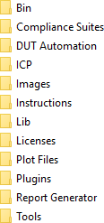

The following table lists the default directory names and their usage:

###### Table 28: Application directories and usage

|  |  |
| --- | --- |
| **Directory names** | **Usage** |
| Bin | Contains application libraries |
| Compliance Suites | Contains test suite specific files |
| DUT Automation | Contains batch files to run DUT in Automated mode |
| ICP | Contains instrument and application specific interface libraries |
| Images | Contains images of the application |
| Lib | Contains utility files specific to the application |
| Licenses | Contains all the license files |
| Plot Files | Contains DPOJET and scope period plots csv |
| Plugins | Contains the dll path for DUT automation |
| Report Generator | Contains style sheets for report generation |
| Table continued… | |

|  |  |
| --- | --- |
| **Directory names** | **Usage** |
| Tools | Contains instrument and application specific files |

## File name extensions

The TekExpress USB4 software uses the following file name extensions:

###### Table 29: File name extension

|  |  |
| --- | --- |
| **File name extension** | **Description** |
| *.TekX | Application session files (the extensions may not be displayed) |
| *.py | Python sequence file. |
| *.xml | Test-specific configuration information (encrypted) files. Application log files |
| *.csv | Test result reports Plot data |
| *.mht | Test result reports (default)  Test reports can also be saved in HTML format |
| *.pdf | Test result reports Application help document |
| *.xslt | Style sheet used to generate reports |
| *.png | Captured images |
| .wfm | Test waveform file |

## View test-related files

Files related to tests are stored in My Documents\TekExpress USB4\Untitled session folder. Each test setup in this folder has both a test setup file and a test setup folder, both with the test setup name. The test setup file is preceded by the TekExpress icon.

Inside the test setup folder is another folder named for the DUT ID used in the test sessions. The default is DUT001.

Inside the DUT001 folder are the session folders and files. Each session also has a folder and file pair, both named for the test session using the naming convention (date)_(time). Each session file is stored outside its matching session folder:

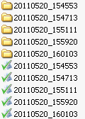

Each session folder contains image files of any plots generated from running the test session. If you selected to save all waveforms or ran tests using prerecorded waveform files, these are included here.

The first time you run a new, unsaved session, the session files are stored in the Untitled Session folder located at X:\TekExpress USB4. When you name and save the session, the files are placed in a folder with the name that you specify. A copy of the test files stay in the Untitled Session folder until you run a new test or until you close the application.

## Handle error codes

The return value of the remote automations at the server-end is OP_STATUS, which changes to a string value depending on its code, and is returned to the client. The values of OP_STATUS are as follows:

|  |  |  |
| --- | --- | --- |
| **Code** | **Value** | **Description** |
| -1 | FAIL | The operation failed |
| 1 | SUCCESS | The operation succeeded |
| 2 | NOT FOUND | Server not found |
| 3 | LOCKED | The server is locked by another client, so the operation cannot be performed |
| 4 | UNLOCK | The server is not locked; lock the server before performing the operation |
| 0 | NULL | Nothing |

 **Note:** The Fail condition for PI commands occurs in any of the following cases: If the server is locked, the application displays "Server is locked by another client".

If the session is unlocked, the application displays "Lock session to execute the command". If the server is not found, the application displays " Server not found-Disconnect!".

If the fail condition is not one of the above types, the application displays "Failed".

# Index

#### A

About SCPI command *54*

Acquisition tab

Acquisition *32*

Activate the license license *11*Application controls

Application controls menu *20*Application directories *114*application directory setup *12*

#### B

Before you click Start *16*

#### C

Command parameters *102*

Configuration tab

Configuration *36*

Configure report view settings *44*Configure the test setup *25*Connected instruments

searching for *24*

Connection requirements *15*

Contacting Tektronix *8*

Conventions *7*

#### D

Delete the run/config session *100*

Deskew

real time oscilloscopes *14*

Device profile connections *15*

Downloading and installing the software Download the software

Install the software *10*

DUT

DUT tab *26*

DUT settings *26*

#### E

Email notification and setup *23*

Equipment setup *15*

Examples *112*

#### F

File name extensions *115*

#### G

Getting help and support *7*

Getting started *9*

GPIB *24*

#### H

Hardware requirements Hardware *9*

#### I

Icons used

symbols *7*

Initial application directory setup *12*Instrument Control Settings *17*Instruments

discovering connected *24*

Interface error codes *116*

#### L

Launch the application *18*

license key *11*

Load the run/config session *100*

load the saved test setup load the test setup *47*

Loading saved waveform files *34*

Log view *40*

Log View *39*

#### M

measurement limits for tests *36*

Minimum system requirements *9*

My TekExpress folder permissions *12*

#### N

Non-VISA *24*

#### O

Options menu

Instrument control settings *24*

Options menu functions *22*

Override the run/config session *102*

#### P

Panels *18*

Preferences tab

Preferences *38*

Prerecorded waveform files *34*

Prerun checklist *16*

Product documents

TekExpress USB4 documents *7*

#### Q

Query the available list in the run/config session *101*

Query the current run/config session *101*

#### R

recalling test setup *46*

References *114*

Remote commands *54*

Report configuration settings *42*

report generation settings

Configure report generation settings *42*

Reports

receiving in email notifications *23*

Reports panel *18*, *42*

Run the run/config saved session *101*

#### S

Save the configured test setup Save the test setup *46*

Save the run/config sessions *100*

Save the test setup *53*

Save the test setup with a different name *53*

Saving test setup *46*SCPI command *54*SCPI Commands

SCPI *54*

Search instruments connected

instruments connected to the application *17*

Select a loaded test setup *48*

Select a pre-run session loaded test setup *48*

Select the tests *30*

set My TekExpress folder permissions *12*

Set the default session *99*Setting up equipment *15*Setting up tests *14*

Setting up the test environment test environment *14*

Setup panel *18*, *25*

Signal Path Compensation (SPC) *14*

Socket configuration for SCPI commands Socket configuration *54*

software version *11*Start the application *18*Status panel *39*

Support *8*

System requirements *9*

#### T

Technical support *8*

Tek Link *24*

TEKEXP:*IDN? *85*

TEKEXP:*OPC? *92*

TEKEXP:ACQUIRE_MODE LIVE *86*

TEKEXP:ACQUIRE_MODE? *86*

TEKEXP:COPYIMAGES <DestinationPath> *98*

TEKEXP:EXIT *92*

TEKEXP:INFO? IMAGE *85*

TEKEXP:INFO? REPORT *84*

TEKEXP:INFO? WFM *85*

TEKEXP:INSTRUMENT, "<InstrumentType>","<value>" *84*

TEKEXP:INSTRUMENT? "<InstrumentType>" *84*

TEKEXP:LASTERROR? *92*

TEKEXP:LIST? DEVICE *82*

TEKEXP:LIST? INSTRUMENT,"<Real Time Scope>" *83*

TEKEXP:LIST? SUITE *82*

TEKEXP:LIST? TEST *82*

TEKEXP:LIST? VERSION *83*

TEKEXP:MODE COMPLIANCE *87*

TEKEXP:MODE? *87*

TEKEXP:POPUP "Yes" *93*

TEKEXP:POPUP? *93*

TEKEXP:REPORT GENERATE *87*TEKEXP:REPORT? "<Device Field>" *88*TEKEXP:REPORTASXML? *98*

TEKEXP:RESULT? "<TestName>" *88*

TEKEXP:RESULT? "<TestName>","<ColumnName>" *88*TEKEXP:RESULT? "<TestName>","<ColumnName>",<RowNumber> *88*

TEKEXP:SELECT DEVICE,"DeviceName" *60*

TEKEXP:SELECT SUITE,"<SuiteName>" *60*

TEKEXP:SELECT TEST,"<ALL>" *61*

TEKEXP:SELECT TEST,"<TestName>",1 *61*

TEKEXP:SELECT? DEVICE *60*

TEKEXP:SELECT? SUITE *60*

TEKEXP:SELECT? TEST *61*

TEKEXP:SELECTID <”TestID”> *98*

TEKEXP:SESSION DEFAULT *99*

TEKEXP:SESSION DELETE, "Session1, Session2" *100*

TEKEXP:SESSION LOAD, “Session Name” *100*

TEKEXP:SESSION RUN, “Session Name’s separated by comma” *101*TEKEXP:SESSION SAVE,"SessionName", "True" *102*TEKEXP:SESSION SAVE,“Session Name” *100*

TEKEXP:SESSION? CURRENT *101*

TEKEXP:SESSION? LIST *101*

TEKEXP:SETUP Default *89*

TEKEXP:SETUP Open,"<SessionName>" *90*

TEKEXP:SETUP Save *89*

TEKEXP:SETUP Save,"<SessionName>" *90*

TEKEXP:SETUP? CURRENT *90*

TEKEXP:STATE RUN *91*

TEKEXP:STATE? *91*

TEKEXP:STATE? SETUP *91*

TEKEXP:TESTINFO? *99*

TEKEXP:VALUE ContinuousRun_Duration,"<Value>" *96*

TEKEXP:VALUE ContinuousRun_RunSessionOptions,"Value" *97*

TEKEXP:VALUE ContinuousRun,"<Value>" *95*

TEKEXP:VALUE DUTID,"Value" *86*

TEKEXP:VALUE GENERAL,"<ParameterName>","<Value>" *76*

TEKEXP:VALUE GENERAL,"View Report After Generating",<value>

*97*

TEKEXP:VALUE

LIMIT,<TestName>,<LimitHeader>,<Value1>,<CompareString>,<Value 2> *93*

TEKEXP:VALUE VERBOSE,"<Value>" *94*

TEKEXP:VALUE

WFMFILE,<TestName>,<AquireType>,<WaveformFileName> *94*

TEKEXP:VALUE? ContinuousRun *95*

TEKEXP:VALUE? ContinuousRun_Duration *96*

TEKEXP:VALUE? ContinuousRun_RunSessionOptions *97*

TEKEXP:VALUE? DUTID *86*

TEKEXP:VALUE? GENERAL,"<ParameterName>" *76*

TEKEXP:VALUE? GENERAL,"Enable Continuous Run" *95*TEKEXP:VALUE? GENERAL,"View Report After Generating" *97*TEKEXP:VALUE? LIMIT,<TestName>,<LimitHeader> *93*

TEKEXP:VALUE? VERBOSE *94*

TEKEXP:VALUE? WFMFILE,<TestName>,<AquireType> *94*

test execution status *39*

Test results

send by email *23*test run preferences *38*Test Selection

Test Selection tab *30*

Test setup files overview Test setup files *46*

Test setup steps *14*Test Status *39*Tests

running *16*

#### V

Verify application installation *12*Version of DUT Automation *29*View a report *45*

View test execution logs *40*

View the test execution status *39*

#### W

waveform acquisition settings *32*

Windows 10 user account setting *11*